Cost-effectiveness and budget impact of whole blood pathogen inactivation in Ghana

W. Alton Russell1,2,3, Shirley Owusu-Ofori4, Alex Owusu-Ofori5,6, Eileen Micah7, Betty Norman7, Brian Custer2,8

1Department of Management Science and Engineering, Stanford University, Stanford, USA

2Vitalant Research Institute, San Francisco, USA

3MGH Institute for Technology Assessment, Harvard Medical School, Boston, USA

4Transfusion Medicine Unit, Komfo-Anokye Teaching Hospital, Kumasi, Ghana

5Laboratory Services Directorate, Komfo-Anokye Teaching Hospital, Kumasi, Ghana

6Department of Clinical Microbiology, Nkrumah University of Science and Technology, Kumasi, Ghana

7Department of Medicine, Komfo-Anokye Teaching Hospital, Kumasi, Ghana

8Department of Laboratory Medicine, University of California, San Francisco, CA

**Corresponding author:** W. Alton Russell, Harvard Medical School, 101 Merrimac St, Room 1032, Boston, MA, 02114, United States. email: [warussell@mgh.harvard.edu](mailto:warussell@mgh.harvard.edu).

**Alt. author contact:** Brian Custer, [bcuster@vitalant.org](mailto:bcuster@vitalant.org).

**Key words:** Pathogen inactivation, blood safety, cost-utility, sub-Saharan Africa

**Running title:** Pathogen inactivation in Ghana

**Summary of main point:** Whole blood pathogen inactivation in Ghana would avert an estimated 12,000 – 26,000 adverse events, eliminate an associated $5M – $12M in direct medical costs annually, and may be cost-saving.

**Word count:** 2719 words

**Abbreviations:** **AVT** antiviral therapy, **FNHTR** febrile non-hemolytic transfusion reaction, **HBV** hepatitis B, **HCV** hepatitis C, **HIV** human immunodeficiency virus, **TT-** transfusion-transmitted, **TTI** transfusion-transmitted infection, **WBPI** while blood pathogen inactivation.

##### 

# Abstract

**Background:** Despite the promise of pathogen inactivation for reducing transfusion-related adverse events in sub-Saharan Africa, no health-economic assessment is publicly available.

**Methods:** We developed a mathematical risk reduction model to estimate the impact of nationwide whole blood pathogen inactivation in Ghana on the incidence of six infectious and one non-infectious transfusion-related adverse events. We estimated the lifetime direct healthcare costs and disability-adjusted life years lost for each adverse event. For HIV, HCV, and HBV, we simulated disease progression using Markov models, accounting for the likelihood and timing of clinical detection and treatment and performed probabilistic and univariate sensitivity analysis.

**Results:** Adding whole blood pathogen inactivation to Ghana’s blood safety portfolio would avert an estimated 20,861 (13,691 – 27,918) adverse events and 43,692 (24,372 – 71,323) disability-adjusted life years annually, primarily by averting bacterial sepsis (53%) and malaria (30%) infections. One year of pathogen inactivation would cost an estimated $8,037,191 ($6,306,066 – $9,907,816) and eliminate $9,565,894 ($5,920,310 – $14,176,289) in direct healthcare spending on transfusion-related adverse events. We estimate a 75% probability that the addition of pathogen inactivation would reduce overall healthcare spending. Findings were most sensitive to uncertainty in the probability that a bacterially contaminated donation causes sepsis.

**Conclusions:** Whole blood pathogen inactivation would substantially reduce the burden of transfusion-related adverse events in Ghana and may reduce overall healthcare spending. Additional benefits not captured by this analysis may include averting secondary transmission of infectious diseases, reducing non-medical costs, and preventing other adverse events.

##### 

# Introduction

Pathogen inactivation of blood components for transfusion is a promising new technology for reducing transfusion-transmitted (TT-) infections (TTIs) and non-infectious transfusion-related adverse events in Sub-Saharan Africa [1]. Pathogen inactivation uses ultraviolet light, often in combination with an additive, to inactivate pathogens in blood components or whole blood [2]. The health-economic consequences of pathogen inactivation of plasma and platelet components has been estimated for different health systems [3–7]. Compared to the European and North American settings where prior analyses have focused, health systems in sub-Saharan Africa often experience greater resource constraints, higher baseline rates of certain transfusion-related adverse events, and more frequent blood shortages [8,9]. Furthermore, use of whole blood rather than derived products limits the applicability of platelet and plasma pathogen inactivation in this context; in Ghana more than 80% of whole blood donations are transfused as a whole blood units [10,11]. For these reasons, whole blood pathogen inactivation (WBPI) may be a more appropriate technology for sub-Saharan Africa. A recent randomized trial analyzed the effectiveness of WBPI for averting TT-malaria in Ghana [12]. However, no health-economic assessment has been published for WBPI in any context, nor for any pathogen inactivation modality in sub-Saharan Africa. We developed a decision-analytic model to estimate how the addition of WBPI to the existing blood safety program in Ghana would impact the number of transfusion-related adverse events and the associated healthcare costs and disability-adjusted life years (DALYs) lost. We also estimated the cost-effectiveness of WBPI.

# Methods

We estimated the health-economic consequences of WBPI in Ghana from a healthcare payer perspective. We considered seven adverse events, including chronic viral TTIs (HIV, HCV, HBV), bacterial TTIs (syphilis, bacterial sepsis), malaria, and febrile non-hemolytic transfusion reactions (FNHTRs), a non-infectious adverse event. We estimated the number of adverse event cases with and without WBPI, the DALYs and healthcare costs incurred per case, the budget impact of WBPI, and the cost-effectiveness in 2019 US dollars spent per DALY averted. We assessed uncertainty through deterministic and probabilistic sensitivity analysis. The model was programmed in R, and all data and code are available in a public repository **[Will create citation before submitting].**

## Risk reduction model structure

Our two-armed decision tree estimated the number of adverse event cases for status quo blood safety interventions and for the status quo plus WBPI. The status quo was to test all donations for HIV-Ab, HBsAg, Anti-HCV Ab, and Anti-treponemal Ab [11]. All parameters values for the risk reduction model are shown in Table 1 <[11–28]>, and mathematical calculations are provided in Section A of the online supplement.

We assumed that each whole blood unit would be transfused to a single recipient (i.e., not fractionated), and we assumed that if one recipient experienced multiple adverse events from a single transfusion event then any adverse event costs would be additive. For each of the six TTIs, the baseline (without WBPI) number of clinically meaningful adverse events was calculated from the annual number of whole blood donations collected nationally, the percent of collected donations not transfused (wastage), the estimated residual risk among donors after TTI screening, and the risk of clinical outcome (i.e., likelihood that transfusion of an infectious unit results in clinically relevant disease). For FNHTR, the baseline rate of clinically relevant adverse events per recipient was extrapolated from local data and prior studies, and the per-donation risk of FNHTR was derived by multiplying the per-recipient rate by the estimated average number of whole blood units transfused per recipient. We assumed some recipients were not at risk of clinical outcomes due to factors such as prior malaria infection, HBV vaccination, and existing HIV infection (Table 1). For each adverse event, we divided by an *x*-fold risk-reduction factor to estimate the number of adverse events when using WBPI. These factors were based on clinical trials where available (malaria, FNHTR) and otherwise sourced from a prior modeling study [3].

## Estimating costs and DALYs from adverse events

We separately modeled a pediatric and adult cohort of transfusion recipients, with an average age of 5 and 40 at the time of transfusion, respectively. Both cohorts had a 5.7% – 8.6% chance of inpatient mortality [29], after which we assumed normal life expectancy based on the age-specific death rate indicator in the World Health Organization Global Health Observatory data repository at baseline [30]. Parameters used to calculate the average DALYs of each adverse event are shown in Supplemental Table S1 <[3,31–34]>. We used estimates of the duration of illness and the associated disability weight to estimate the average years lived with disability (YLD) for each adverse event. We calculated the average years of life lost (YLL) based on the estimated increased risk of inpatient mortality for malaria in the pediatric cohort and sepsis in both cohorts. For each chronic viral infection, we developed Markov models for both the pediatric and adult cohorts to estimated medical costs and DALYs lost related to the infection over the remaining lifetime of transfusion recipients.

We used a micro-costing approach to estimate the average health care spending associated with each transfusion-related adverse event. For most costs, authors with relevant clinical experience at the Komfo Anokye Teaching Hospital (KATH) in Kumasi, Ghana, estimated the costs and utilization patterns for resources used to treat each adverse event. For HIV, we assumed infections that had not yet progressed to AIDS would be detected in an outpatient clinic and used empirical costing estimates from a recent study of healthcare costs for patients initiating antiviral therapy (AVT) [35]. We treated FNHTR, malaria, syphilis, and sepsis as acute infections and assumed associated costs and morbidity occurred within a year of transfusion. For HIV, HBV, and HCV. we estimated the annual resource utilization and associated costs for each disease state in the Markov models. Supplemental Table S2 <[29,35]> contains estimates and uncertainty ranges for all micro-costing parameters, and Supplemental Table S3 contains the calculations used for the four acute adverse events and for each disease state of the chronic viral infections.

The Markov Models for HCV, HBV, and HIV captured the disease natural history, treatment initiation, and treatment effectiveness. We used a one-year cycle length, discounted future costs at 3% annually, and used the cycle tree method to correct for discretization error [36]. All other transition probabilities and their sources are listed in Supplemental Table S4 <[33,34,37,38]>. The supplement also contains schematics for the transition matrix for each chronic adverse event (Supplementary Figures S1 – S3) and Markov trace plots of the proportion of transfusion recipients in each disease state over time (Supplementary Figures S4 – S6).

For HCV, our natural history model and treatment efficacy estimates were based on a health economic model developed for The Gambia [34], and transitions into treatment were estimated based on authors’ clinical experience. Within the model, a small percentage of infections are detected during the acute phase in the first year and receive AVT; otherwise, recipients have subclinical acute infections. Some initially subclinical infections progress through chronic HCV disease states. A percentage of patients in the compensated or decompensated cirrhosis disease states are detected each year, and those patients receive AVT. AVT clears most HCV infections, but some patients experience treatment failure with disease progression while receiving monitoring and care.

For HBV, our natural history model and treatment efficacy estimates were based on a health economic model developed for South Africa [33]. In the model, a small fraction of acute infections are detected and receive monitoring and care during the first year, but most infections are subclinical during the acute phase. Subclinical infections that progress to the immune reactive, compensated cirrhosis, or decompensated cirrhosis states have an annual probability of clinical detection, at which point AVT is initiated. Subclinical patients in the chronic HBeAg- phase also have an annual probability of detection. Those patients transition to receiving monitoring and care without AVT, but some initiate AVT each year due to clinical indications such as a spike in viral load. We assumed patients on AVT do not progress to later disease states and would continue with AVT and monitoring for their lifetimes. However, a small annual risk of developing hepatocellular carcinoma remains for those who developed cirrhosis before AVT initiation.

For HIV, we constructed a natural history model and calibrated the annual probability of progression to AIDS, death from HIV, and death from AIDS to a longitudinal study of HIV progression from Uganda (Figure S7) [38]. We estimated the annual probability of initiating AVT based on HIV progression based on the authors’ clinical experience, and we assumed patients who initiated AVT before progressing to AIDS continue with treatment for the remainder of their lives and have a normal life expectancy. Annual costs for those who initiated AVT before progressing to AIDS are based on an empirical study conducted in HIV clinics in Ghana that found that on average, medical expenses were highest in the year of AVT initiation and tapered off over three years [35]. For patients who initiate AVT after progressing to AIDS, we assumed they would receive a diagnosis and initiate AVT during a hospitalization for AIDS complications and therefore incur substantially higher costs in the first two years as compared to those initiating AVT with HIV. We also assumed those initiating AVT with AIDS would have a higher risk of dying during the first two years of AVT. After two years on AVT, we assumed most surviving AIDS patients would have recovered their CD4 counts and have the same annual costs and risk of death as any other AVT patient. We assumed a minority of surviving AIDS patients would have residual disability due to AIDS-related illnesses such as stroke or kidney failure. We assumed a higher annual cost and mortality risk for these patients.

## Uncertainty analysis

For each input parameter, we estimated a range of likely values for deterministic sensitivity analysis and assigned a distribution for probabilistic sensitivity analysis. We used beta distributions when estimates were based on counts for a binary outcome or when the parameter source used a beta distribution; otherwise, we sampled each parameter from a PERT distribution. For all outcomes, we reported the expected value from the base case scenario and a 95% uncertainty interval based on the 2.5th and 97.5th quantiles of the outcome across 10,000 iterations of probabilistic sensitivity analysis. In a scenario analysis, we approximated secondary infections by assuming each surviving recipient infected with HIV, HBV, or HCV infects one other person during the first year following transfusion.

# Results

The number of modeled adverse events per year without WBPI was 26,600 (19,283 – 35,413). WBPI reduced the number of adverse events by 20,861 (13,691 – 27,918) to 5,739 (3,801 – 10,616) per year. 53% of averted adverse event cases were bacterial sepsis infections; 30% were malaria; 9% were FNHTR; 4% were HCV; 3% were HBV; 0.76% were HIV; and 0.27% were syphilis (Table 2). The estimated DALYs lost due without WBPI was 45,786 (25,935 – 74,414), of which 93% was due to sepsis infections. WBPI would avert an estimated 43,692 (24,372 – 71,323) DALYs.

The estimated net present cost per adverse event ranged from $2.59 ($1.31 – $4.47) for syphilis to $1,500.99 ($1,024.96 – $2,100.01) for HCV. Because most chronic viral infections were not immediately detected, less than 10% of healthcare costs associated with HIV, HBV, and HCV occurred in the first post-transfusion year (Supplementary Table S4). The total net present healthcare costs due to adverse events was $10,426,999 ($6,632,680 – $15,363,774) without WBPI and $861,105 ($593,666 – $1,363,059) with WBPI. Of the adverse events evaluated, sepsis infection had only the fourth highest per-case cost at $667.29 ($529.28 – $838.82) but represented the majority of healthcare spending due to adverse events without WBPI (74%) and the majority of net present healthcare savings due to PI (78%).

One year of WBPI in Ghana would cost an estimated $8,037,191 ($6,306,066 – $9,907,816) and reduce net present healthcare spending by $9,565,894 ($5,920,310 – $14,176,289) due to averted adverse events, resulting in an annual net savings of $1,528,702 (-$2,196,926 – $5,873,958) (Figure 2). WBPI led to an overall reduction in net present healthcare spending in 75% of probabilistic sensitivity analysis iterations (Figure 3). Across the 25% iterations where WBPI had a positive net cost, WBPI never cost more than $155 per DALY averted.

In univariate sensitivity analysis, our conclusion that WBPI would be cost-saving was sensitive to 3 input parameters. WBPI had a positive net present cost at the minimum value of our uncertainty range for 2 parameters: the baseline risk of bacterial contamination (net present cost of $118,470) and the risk of clinical outcome for sepsis ($2,806,280). WBPI had a positive net present cost of $99,182 at the maximum value of our uncertainty range for the per-donation cost of WBPI (Figure 4).

In a scenario analysis where we accounted for one secondary infection for all HBV, HCV, and HIV-infected recipients, the net present health savings from WBPI increased from $9,565,894 to $11,385,577 ($7,435,973 – $16,475,524) annually. In this scenario, WBPI reduced overall healthcare costs in 94% of iterations.

# Discussion

Our study suggests that adding WBPI to the existing blood safety portfolio would substantially reduce the burden of transfusion-related adverse events in Ghana. In our analysis, the estimated cost per DALY averted never approached Ghana’s per capita gross national income – $2,220 in 2019 [39] – in any iteration of sensitivity analysis. We estimated a 75% probability that WBPI would lead to a net reduction in healthcare costs, but this increased to 94% when factoring in healthcare costs for secondary transmission of HIV, HBV, and HCV. We took a healthcare payer perspective and did not consider costs such as family caregiver time, productivity loss, or transportation costs. We also did not evaluate all types of adverse events for which WBPI may reduce risk, which could include emerging infectious diseases not yet identified as blood safety threats, and we did not quantify the associated reductions in death and disability. Due to these factors, the total societal benefit of WBPI likely exceeds the direct healthcare-related impact as estimated in this analysis.

Our analysis is the most comprehensive estimation of the burden of transfusion-related adverse events to date for a sub-Saharan African setting. We developed a new approach to account for subclinical disease and the timing and likelihood of chronic disease detection. This approach, combined with other therapeutic developments such as price reductions for HIV antiviral therapy drugs [40] and greater immunity to HBV through vaccination [41], led to lower estimates of the per-infection costs for TT-HBV, TT-HCV, and TT-HIV events as compared to past analyses of blood safety interventions in sub-Saharan Africa [29,37,42]. To our knowledge, this is the first study to estimate healthcare costs and DALYs lost due to TT-sepsis in a sub-Saharan African setting. We estimated that TT-sepsis is responsible for the majority of morbidity, morbidity, and costs associated with transfusion-related adverse events in Ghana. A systematic review recently estimated that the rate of bacterial contamination of blood products in African settings ranged from 0% to 17.9% [43], suggesting TT-sepsis may be an underappreciated blood safety threat with substantial burden in many African counties. The probability that a bacterially contaminated donation will lead to clinical disease in a transfusion recipient has not been adequately studied and was a key driver of uncertainty in our findings.

Our study has several limitations. Due to lack of data, we did not account for variability in the number of whole blood units transfused per recipient, nor the association between mortality and the number of units transfused. This could lead to an overestimation of the benefits of WBPI if multiply transfused recipients, who are at an elevated risk of adverse events, have lower expected survival, as has been estimated in other settings [44]. Data on the rate of transfusion-related adverse events in Ghana, and in sub-Saharan Africa generally, are limited. The benefit of WBPI depends on the baseline residual risk of each adverse event, and updated risk estimates using hemovigilance data, if available, could improve estimation. While our detailed micro-costing approach to estimating the disease trajectories and associated healthcare costs for adverse events was based on clinical expertise, a rigorous empirical study would enhance precision.

Our analysis provides further evidence that WBPI is a promising technology for sub-Saharan Africa. Future research could further elucidate the societal impact of WBPI and other blood safety technologies by improving estimation of the burden of illness from transfusion-related adverse events, estimating other impacts beyond direct healthcare spending, and by considering other settings in sub-Saharan Africa.

##### 

# Declarations

**Funding:** This work was supported by Terumo BCT, Inc. (Lakewood, Colorado, USA). Terumo BCT provided no editorial control over the research or the manuscript.

**Acknowledgements:** The authors thank Marion Vermeulen of the South African National Blood Supply for providing unpublished hemovigilance data for syphilis; Dr. Lucy Asamoah-Akuoko of the National Blood Service, Ghana, for providing unpublished data on the percent of whole blood units not transfused; and Nigel Talboys and Eric Mwenda of Terumo BCT, Inc. for providing estimated costs for whole blood pathogen inactivation.

**Potential Conflicts of Interest:** WAR received consulting fees from Terumo BCT, Inc. (Lakewood, Colorado, USA) for developing the submitted work. SOO received honoraria from Terumo BCT outside the submitted work. BC reports grants from Grifols Diagnostic Solutions (Barcelona, Spain). Authors AOO, EM, and BN affirm that they have no conflicts.

**Ethics/Consent:** This analysis was based on public data and was exempt from institutional ethics review.

**Data and materials:** All data and materials have been uploaded to a public repository.

**Code availability:** All code has been uploaded to a public repository.

##### 

# References

1. Ware AD, Jacquot C, Tobian AAR, Gehrie EA, Ness PM, Bloch EM. Pathogen reduction and blood transfusion safety in Africa: strengths, limitations and challenges of implementation in low-resource settings. *Vox Sanguinis*. 2018;113(1):3-12. doi:[10.1111/vox.12620](https://doi.org/10.1111/vox.12620)

2. Prowse CV. Component pathogen inactivation: A critical review. *Vox Sanguinis*. 2013;104(3):183-199. doi:[10.1111/j.1423-0410.2012.01662.x](https://doi.org/10.1111/j.1423-0410.2012.01662.x)

3. Custer B, Agapova M, Martinez RH. The cost-effectiveness of pathogen reduction technology as assessed using a multiple risk reduction model. *Transfusion*. 2010;50(11):2461-2473. doi:[10.1111/j.1537-2995.2010.02704.x](https://doi.org/10.1111/j.1537-2995.2010.02704.x)

4. Agapova M, Lachert E, Brojer E, Letowska M, Grabarczyk P, Custer B. Introducing pathogen reduction technology in Poland: A cost-utility analysis. *Transfus Med Hemother*. 2015;42:158-165. doi:[10.1159/000371664](https://doi.org/10.1159/000371664)

5. Bell CE, Botteman MF, Gao X, et al. Cost-effectiveness of transfusion of platelet components prepared with pathogen inactivation treatment in the United States. *Clinical Therapeutics*. 2003;25(9):2464-2486. doi:[10.1016/S0149-2918(03)80288-6](https://doi.org/10.1016/S0149-2918(03)80288-6)

6. Babigumira JB, Lubinga SJ, Castro E, Custer B. Cost-utility and budget impact of methylene blue-treated plasma compared to quarantine plasma. *Blood Transfusion*. 2018;16(2):154-162. doi:[10.2450/2016.0130-16](https://doi.org/10.2450/2016.0130-16)

7. Canadian Agency for Drugs and Technologies in Health (CADTH). Octaplas compared with fresh frozen plasma to reduce the risk of transmitting lipid-enveloped viruses: an economic analysis and budget impact analysis. *CADTH technology overviews*. 2010;1(1):e0106. [http://www.ncbi.nlm.nih.gov/pubmed/22977394 http://www.pubmedcentral.nih.gov/articlerender.fcgi?artid=PMC3411137](http://www.ncbi.nlm.nih.gov/pubmed/22977394%20http://www.pubmedcentral.nih.gov/articlerender.fcgi?artid=PMC3411137).

8. Bloch EM, Vermeulen M, Murphy E. Blood Transfusion Safety in Africa: A Literature Review of Infectious Disease and Organizational Challenges. *Transfusion Medicine Reviews*. 2012;26(2):164-180. doi:[10.1016/j.tmrv.2011.07.006](https://doi.org/10.1016/j.tmrv.2011.07.006)

9. Barro L, Drew VJ, Poda GG, et al. Blood transfusion in sub-Saharan Africa: understanding the missing gap and responding to present and future challenges. *Vox Sanguinis*. 2018;113(8):726-736. doi:[10.1111/vox.12705](https://doi.org/10.1111/vox.12705)

10. Allain JP, Goodrich R. Pathogen reduction of whole blood: utility and feasibility. 2017;27:320-326. doi:[10.1111/tme.12456](https://doi.org/10.1111/tme.12456)

11. World Health Organisation. *Global Status Report on Blood Safety and Availability*.; 2017:1-73. <http://apps.who.int/iris/bitstream/handle/10665/254987/9789241565431-eng.pdf?sequence=1>.

12. Allain JP, Owusu-Ofori AK, Assennato SM, Marschner S, Goodrich RP, Owusu-Ofori S. Effect of Plasmodium inactivation in whole blood on the incidence of blood transfusion-transmitted malaria in endemic regions: The African Investigation of the Mirasol System (AIMS) randomised controlled trial. *The Lancet*. 2016;387(10029):1753-1761. doi:[10.1016/S0140-6736(16)00581-X](https://doi.org/10.1016/S0140-6736(16)00581-X)

13. Mafirakureva N, Khoza S, Hassall O, et al. Profiles of blood and blood component transfusion recipients in Zimbabwe. *Blood Transfusion*. 2015;13(4):600-609. doi:[10.2450/2015.0019-15](https://doi.org/10.2450/2015.0019-15)

14. Osei EN, Odoi AT, Owusu-Ofori S, Allain JP. Appropriateness of blood product transfusion in the Obstetrics and Gynaecology (O&G) department of a tertiary hospital in West Africa. *Transfusion Medicine*. 2013;23(3):160-166. doi:[10.1111/tme.12028](https://doi.org/10.1111/tme.12028)

15. Jayaraman S, Chalabi Z, Perel P, Guerriero C, Roberts I. The risk of transfusion-transmitted infections in sub-Saharan Africa. *Transfusion*. 2010;50(2):433-442. doi:[10.1111/j.1537-2995.2009.002402.x](https://doi.org/10.1111/j.1537-2995.2009.002402.x)

16. Adjei AA, Kuma GK, Tettey Y, et al. Bacterial contamination of blood and blood components in three major blood transfusion centers, Accra, Ghana. *Japanese Journal of Infectious Diseases*. 2009;62(4):265-269.

17. Allotey A. Bacterial contamination of blood and blood components at the Accra area blood centre of the National Blood Service, Ghana. *Africa Sanguine*. 2019;21(1):31.

18. Owusu-ofori AK. *Transfusion transmitted malaria and bacterial infections in a malaria endemic region [Doctoral Dissertation]*. Liverpool: University of Liverpool; 2012. <http://livrepository.liverpool.ac.uk/6173>.

19. Opoku-Okrah C, Feglo P, Amidu N, Dakorah MP. Bacterial contamination of donor blood at the Tamale Teaching Hospital, Ghana. *African Health Sciences*. 2009;9(1):13-18. doi:[10.4314/AHS.V9I1.7097](https://doi.org/10.4314/AHS.V9I1.7097)

20. Boye A, Daniel D, Samuel A, James A, Mate-Siakwa P. Bacterial Contamination of at-Point-of Transfusion Blood in a Tertiary Hospital in Ghana. *EC Bacteriology and Virology*. 2016;4(May):121-128. <https://www.researchgate.net/publication/302874421>.

21. Owusu-Ofori AK, Owusu-Ofori SP, Bates I. Detection of adverse events of transfusion in a teaching hospital in Ghana. *Transfusion Medicine*. 2017;27(3):175-180. doi:[10.1111/tme.12392](https://doi.org/10.1111/tme.12392)

22. Jimenez-Marco T, Garcia-Recio M, Girona-Llobera E. Our experience in riboflavin and ultraviolet light pathogen reduction technology for platelets: from platelet production to patient care. *Transfusion*. 2018;(July):1-9. doi:[10.1111/trf.14797](https://doi.org/10.1111/trf.14797)

23. Sluis JJ van der, Kate FJW ten, Vuzevski VD, Kothe FC, Aelbers GMN, Eijk RVW van. Transfusion syphilis, survival of Treponema pallidum in stored donor blood. *Vox Sanguinis*. 1985;49(6):390-399. doi:[10.1111/j.1423-0410.1985.tb01131.x](https://doi.org/10.1111/j.1423-0410.1985.tb01131.x)

24. Adegoke AO, Akanni OE. Survival of treponema pallidum in banked blood for prevention of syphilis transmission. *North American Journal of Medical Sciences*. 2011;3(7):329-332. doi:[10.4297/najms.2011.3329](https://doi.org/10.4297/najms.2011.3329)

25. Owusu-Ofori AK, Parry CM, Bates I. Transfusion-transmitted syphilis in teaching hospital, Ghana. *Emerging Infectious Diseases*. 2011;17(11):2080-2082. doi:[10.3201/eid1711.110282](https://doi.org/10.3201/eid1711.110282)

26. World Health Organization. *WHO and UNIFEF estimates of national immunization coverage in Ghana*. Geneva; 2020:1-22. <https://www.who.int/immunization/monitoring_surveillance/data/gha.pdf>.

27. World Health Organization. *HIV Country Profiles*.; 2019:1-6. <https://cfs.hivci.org/country-factsheet.html>.

28. United Nations Population Division. *World Population Prospects*. New York; 2019. <https://population.un.org/wpp/Download/Standard/Population/>.

29. Hulst M van, Sagoe KWCC, Vermande JE, et al. Cost-effectiveness of HIV screening of blood donations in Accra (Ghana). *Value in Health*. 2008;11(5):809-819. doi:[10.1111/j.1524-4733.2008.00337.x](https://doi.org/10.1111/j.1524-4733.2008.00337.x)

30. World Health Organization. Global Health Observatory data repository. <https://apps.who.int/gho/data/node.main>. Accessed July 2, 2020.

31. Lewis JM, Feasey NA, Rylance J. Aetiology and outcomes of sepsis in adults in sub-Saharan Africa: A systematic review and meta-analysis. *Critical Care*. 2019;23(1):212. doi:[10.1186/s13054-019-2501-y](https://doi.org/10.1186/s13054-019-2501-y)

32. Salomon JA, Haagsma JA, Davis A, et al. Disability weights for the Global Burden of Disease 2013 study. *The Lancet Global Health*. 2015;3(11):e712-e723. doi:[10.1016/S2214-109X(15)00069-8](https://doi.org/10.1016/S2214-109X(15)00069-8)

33. Fraser I, Burger J, Lubbe M, Dranitsaris G, Sonderup M, Stander T. Cost-effectiveness modelling of Sofosbuvir-containing regimens for chronic genotype 5 hepatitis C virus infection in South Africa. *PharmacoEconomics*. 2016;34(4):403-417. doi:[10.1007/s40273-015-0356-x](https://doi.org/10.1007/s40273-015-0356-x)

34. Nayagam S, Conteh L, Sicuri E, et al. Cost-effectiveness of community-based screening and treatment for chronic hepatitis B in The Gambia: an economic modelling analysis. *The Lancet Global Health*. 2016;4(8):e568-e578. doi:[10.1016/S2214-109X(16)30101-2](https://doi.org/10.1016/S2214-109X(16)30101-2)

35. Mikkelsen E, Hontelez JAC, Nonvignond J, et al. The costs of HIV treatment and care in Ghana. *AIDS*. 2017;31(16):2279-2286. <https://www.ncbi.nlm.nih.gov/pmc/articles/PMC5642329/pdf/aids-31-2279.pdf>.

36. Naimark DMJ, Kabboul NN, Krahn MD. The half-cycle correction revisited: Redemption of a kludge. *Medical Decision Making*. 2013;33(7):961-970. doi:[10.1177/0272989X13501558](https://doi.org/10.1177/0272989X13501558)

37. Mafirakureva N, Mapako T, Khoza S, et al. Cost effectiveness of adding nucleic acid testing to hepatitis B, hepatitis C, and human immunodeficiency virus screening of blood donations in Zimbabwe. *Transfusion*. 2016;56(12):3101-3111. doi:[10.1111/trf.13858](https://doi.org/10.1111/trf.13858)

38. Morgan D, Mahe C, Mayanja B, Okongo JM, Lubega R, Whitworth JAG. HIV-1 infection in rural Africa: Is there a difference in median time to AIDS and survival compared with that in industrialized countries? *AIDS*. 2002;16(4):597-603. doi:[10.1097/00002030-200203080-00011](https://doi.org/10.1097/00002030-200203080-00011)

39. The World Bank. World Bank Open Data. 2021. <https://data.worldbank.org/>. Accessed March 6, 2021.

40. Lee JSF, Sagaon Teyssier L, Dongmo Nguimfack B, et al. An analysis of volumes, prices and pricing trends of the pediatric antiretroviral market in developing countries from 2004 to 2012. *BMC Pediatrics*. 2016;16(1):1-8. doi:[10.1186/s12887-016-0578-x](https://doi.org/10.1186/s12887-016-0578-x)

41. Sarkodie F, Ullum H, Owusu-Dabo E, Owusu-Ofori S, Owusu-Ofori A, Hassall O. A novel strategy for screening blood donors for syphilis at Komfo Anokye Teaching Hospital, Ghana. *Transfusion Medicine*. 2016;26(1):63-66. doi:[10.1111/tme.12279](https://doi.org/10.1111/tme.12279)

42. Custer B, Janssen MP, Hubben G, Vermeulen M, Hulst M van. Development of a web-based application and multicountry analysis framework for assessing interdicted infections and cost-utility of screening donated blood for HIV, HCV and HBV. *Vox Sanguinis*. 2017;112(6):526-534. doi:[10.1111/vox.12538](https://doi.org/10.1111/vox.12538)

43. Ahmad Y, Heroes AS, Hume HA, et al. Bacterial contamination of blood products in Africa. *Transfusion*. January 2021:trf.16262. doi:[10.1111/trf.16262](https://doi.org/10.1111/trf.16262)

44. Russell WA, Stramer SL, Busch MP, Custer B. Screening the blood supply for Zika virus in the 50 U.S. States and Puerto Rico: A cost-effectiveness analysis. *Annals of Internal Medicine*. 2019;170(3):164-174. doi:[10.7326/M18-2238](https://doi.org/10.7326/M18-2238)

##### 

**Table 1** Parameters for modeling the risk of adverse events with and without whole blood pathogen inactivation

| **Risk model parameters** | **Value (range); distribution1** | **Source** |
| --- | --- | --- |
| **System parameters** | | |
| Percent recipients who are pediatric | 19% (15%–25%); PERT | Mafirakureva 2015 |
| Number of components transfused | 160000 (128000–192000); PERT | WHO 2017 |
| Percent of donations not transfused | 9% (1%–17%); PERT | Personal communication2 |
| Cost of WBPI per treatment (in $) | $46 ($37–$55); PERT | Personal communication3 |
| **Baseline risk** | | |
| HIV | 0.112% (0.036%–0.324%); PERT | Jayaraman 2010 |
| Sepsis (bacterial contamination) | 15.1% (11.8%–18.8%); Beta(86, 483) | Pooled analysis4 |
| HCV | 0.54% (0.135%–1.22%); PERT | Jayaraman 2010 |
| HBV | 0.94% (0.235%–2.12%); PERT | Jayaraman 2010 |
| Syphilis | 0.064% (0.034%–0.092%); PERT | Personal communication5 |
| Malaria | 25% (19.8%–30.2%); Beta(91, 276) | Allain 2016 |
| FNHTR | 3.63% (2.2%–5.43%); Beta(26, 691.12) | Calculated |
| **Symptomatic outcome risk** | | |
| HIV | 98.3% (50%–100%); PERT | WHO 2019 |
| Sepsis | 47.8% (20%–70%); PERT | Owusu-Ofori 2012 |
| HCV | 100% (50%–100%) | Agapova 2015 |
| HBV | 46% (40%–70%); PERT | WHO/UNICEF 20206 |
| Syphilis | 57% (0%–100%); PERT | Owusu-Ofori 20117 |
| Malaria | 18.5% (8.4%–33.7%); PERT | Calculated8 |
| FNHTR | 100% (NA%–NA%) | Assumed |
| **Fold reduction of WBPI** | | |
| HIV | 10 (5–20); PERT | Agapova 2015 |
| Sepsis | 25 (10–40); PERT | Estimated9 |
| HCV | 10 (5–20); PERT | Agapova 2015 |
| HBV | 10 (5–20); PERT | Agapova 2015 |
| Syphilis | 20 (10–40); PERT | Agapova 2015 |
| Malaria | 6.05 (1–20); PERT | Allain 2016 |
| FNHTR | 1.5 (1–3); PERT | Estimated10 |
| 1‘Min’ and ‘Max’ values were used for deterministic sensitivity analysis; ‘Distribution’ was used for probabilistic sensitivity analysis. Beta distribution was used when proportion count data were available; PERT distribution using the point estimate as mean was used otherwise. | | |
| 2Based on unpublished data for KATH collected by the authors and data for the Southern Area Blood Center provided by Dr. Lucy Asamoah-Akuoko of the National Blood Service, Ghana, personal communication. | | |
| 3Provided by Nigel Talboys and Eric Mwenda, Terumo BCT, personal communication. | | |
| 4We pooled estimates of the rate of bacterial contamination in whole blood units in Ghana from five analyses: 9/100 units were contaminated in Allotey 2019; 24/192 in Adjeu 2009; 16/97 in Boye 2016; 14/80 in Opuku-Okrah 2009; and 23/100 in Owusu-Ofori 2012. | | |
| 5Estimated based on rate of repeat reactive Treponema pallidum hemagglutination assay (TPHA) positivity in Durban and Johannesburg provided by Marion Vermeulen of the South African National Blood Service, personal communication. | | |
| 6Assumed HBV vaccinated individuals have no risk of clinical outcomes. Estimated that 95% of recipients under 25 would be vaccinated based on WHO/UNICEF 2020 report and that 56% of population is under 20 based on UN 2019. | | |
| 7Assumed transmission occurred in donations stored less than 4 days only based on van der Sluis 1985 and Adegoke 2011. Estimated that 57% of donations are stored less than 4 days from Owusu-Ofori 2011. | | |
| 8Calculated from Allain 2016; see supplemental methods. | | |
| 9Agapova 2015 used 50, adjusted downwards based on authors' estimation. | | |
| 10Jimenez-Marco 2018 estimated a 2.08-fold reduction in pathogen reduced platelets. Data from Ghana reports a decrease across randomized groups from 11/255 to 17/303 implying a fold risk reduction of 1.3. Based on both studies, chose 1.5 as base case estimate. | | |

**Table 2** Estimated cases and healthcare spending incurred for each adverse event with and without whole blood pathogen inactivation for one year. DALY, disability-adjusted life year; WBPI, whole blood pathogen inactivation; YLD, years lived with disability; YLL, years of life lost.

| **Outcome** | **Sepsis** | **Malaria** | **FNHTR** | **Syphilis** | **HBV** | **HCV** | **HIV** |
| --- | --- | --- | --- | --- | --- | --- | --- |
| Cases without WBPI | 11,581 (6,614 – 16,940) | 7,414 (4,009 – 11,671) | 5,812 (3,802 – 8,328) | 58 (19 – 105) | 693 (273 – 1,283) | 866 (352 – 1,586) | 176 (63 – 335) |
| Cases with WBPI | 463 (240 – 912) | 1,225 (398 – 5,157) | 3,874 (2,250 – 6,555) | 3 (1 – 6) | 69 (25 – 164) | 87 (31 – 208) | 18 (5 – 40) |
| Cases reduced by WBPI | 11,117 (6,364 – 16,187) | 6,189 (2,430 – 9,711) | 1,937 (266 – 3,701) | 56 (18 – 99) | 624 (246 – 1,157) | 779 (311 – 1,395) | 159 (56 – 307) |
| Net present cost per case | $667.29 ($529.28 – $838.82) | $27.37 ($20.82 – $35.03) | $81.63 ($56.83 – $110.66) | $2.59 ($1.31 – $4.47) | $786.26 ($583.67 – $1,019.04) | $1,500.99 ($1,024.96 – $2,100.01) | $1,006.63 ($930.29 – $1,253.46) |
| YLD per case | 0.01 (0.0082 – 0.013) | 0.0012 (0.00075 – 0.0019) | 0.0018 (0.00092 – 0.0032) | 0.027 (0.018 – 0.043) | 0.43 (0.33 – 0.49) | 1 (0.73 – 1.5) | 1.3 (1 – 1.5) |
| YLL per case | 3.7 (2.6 – 4.9) | 0.12 (0.036 – 0.22) | 0 (0 – 0) | 0 (0 – 0) | 0.84 (0.75 – 0.93) | 0.082 (0.047 – 0.14) | 1.7 (1 – 2.9) |
| Total net present cost reduced by WBPI | $7,418,520 ($4,028,346 – $11,943,554) | $169,403 ($63,509.70 – $287,738) | $158,143 ($19,622.19 – $318,800) | $144.05 ($43.98 – $313.18) | $490,474 ($186,380 – $944,024) | $1,169,325 ($430,608 – $2,357,230) | $159,884 ($59,890.44 – $330,244) |
| DALYs averted by WBPI | 40,786.81 (21,764.67 – 68,273.52) | 759.00 (166.34 – 1,562.94) | 3.52 (0.40 – 8.23) | 1.53 (0.49 – 3.12) | 790.71 (312.87 – 1,456.77) | 881.56 (317.86 – 1,800.75) | 468.46 (161.93 – 987.60) |

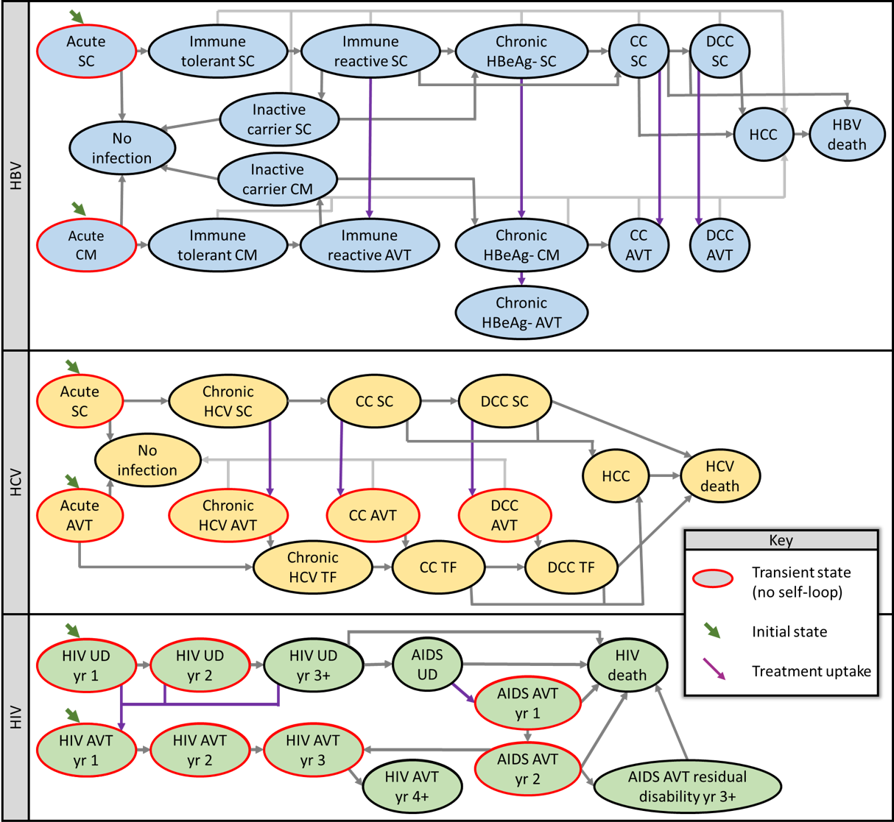

**Fig. 1.** Schematics for Markov models used to estimate net-present lifetime costs for chronic viral infections. Death from other causes possible from any disease state (not shown). Abbreviations AVT, antiviral therapy, CC, compensated cirrhosis, CM, clinical monitored, DCC, decompensated cirrhosis, HCC, hepatocellular carcinoma, HBV, hepatitis B, HCV, hepatitis C, HIV, human immunodeficiency virus, TF, treatment failure, UD, undetected, SC, subclinical

##### 

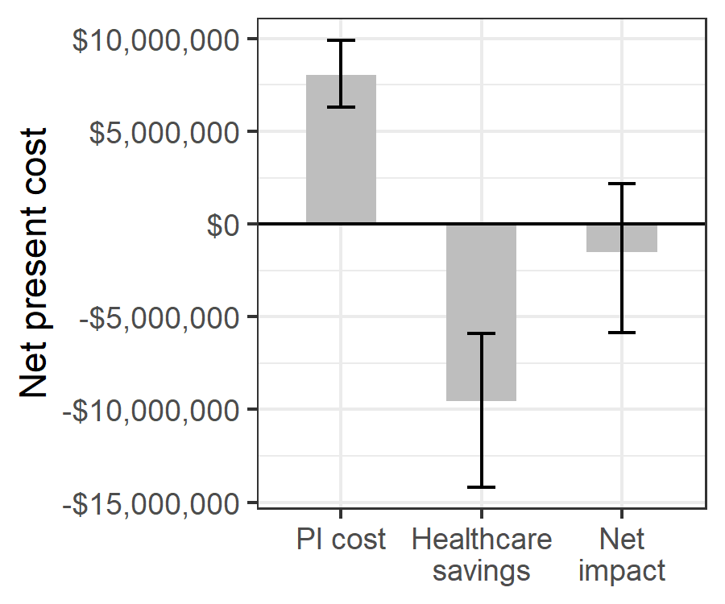

Fig. 2. Estimated net impact on healthcare spending of whole blood pathogen inactivation. Net impact is the cost of pathogen inactivation minus the net present healthcare savings from avert transfusion-related adverse events.

##### 

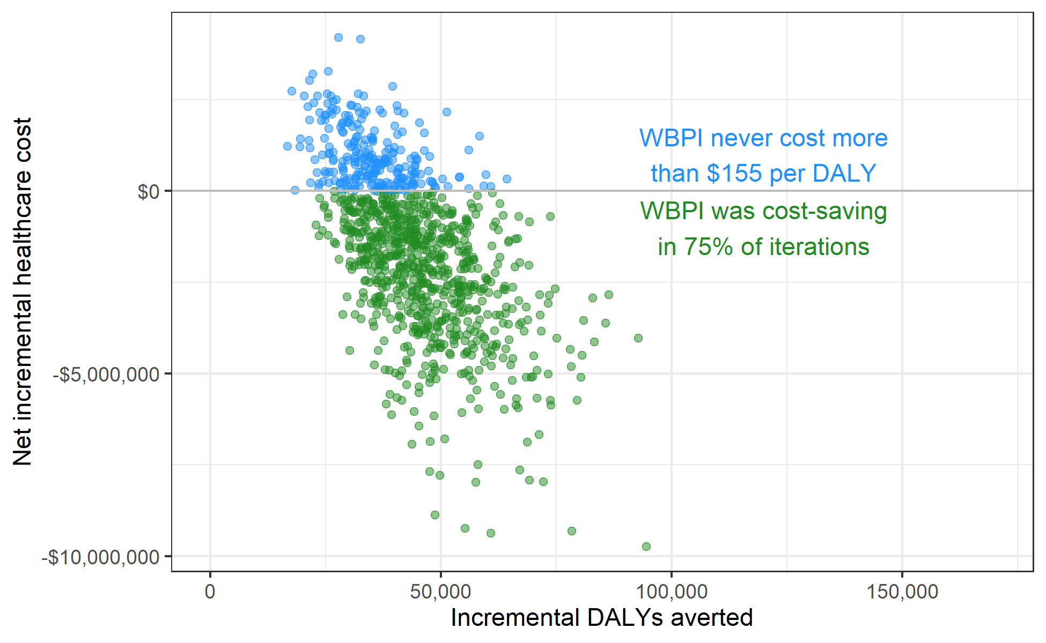

**Fig. 3.** Scatterplot showing the incremental healthcare costs and DALYs averted for WBPI across 10,000 probabilistic sensitivity analysis iterations. WBPI was cost-saving in 75.1% and cost less than $100 per DALY in 98.9% of iterations.

##### 

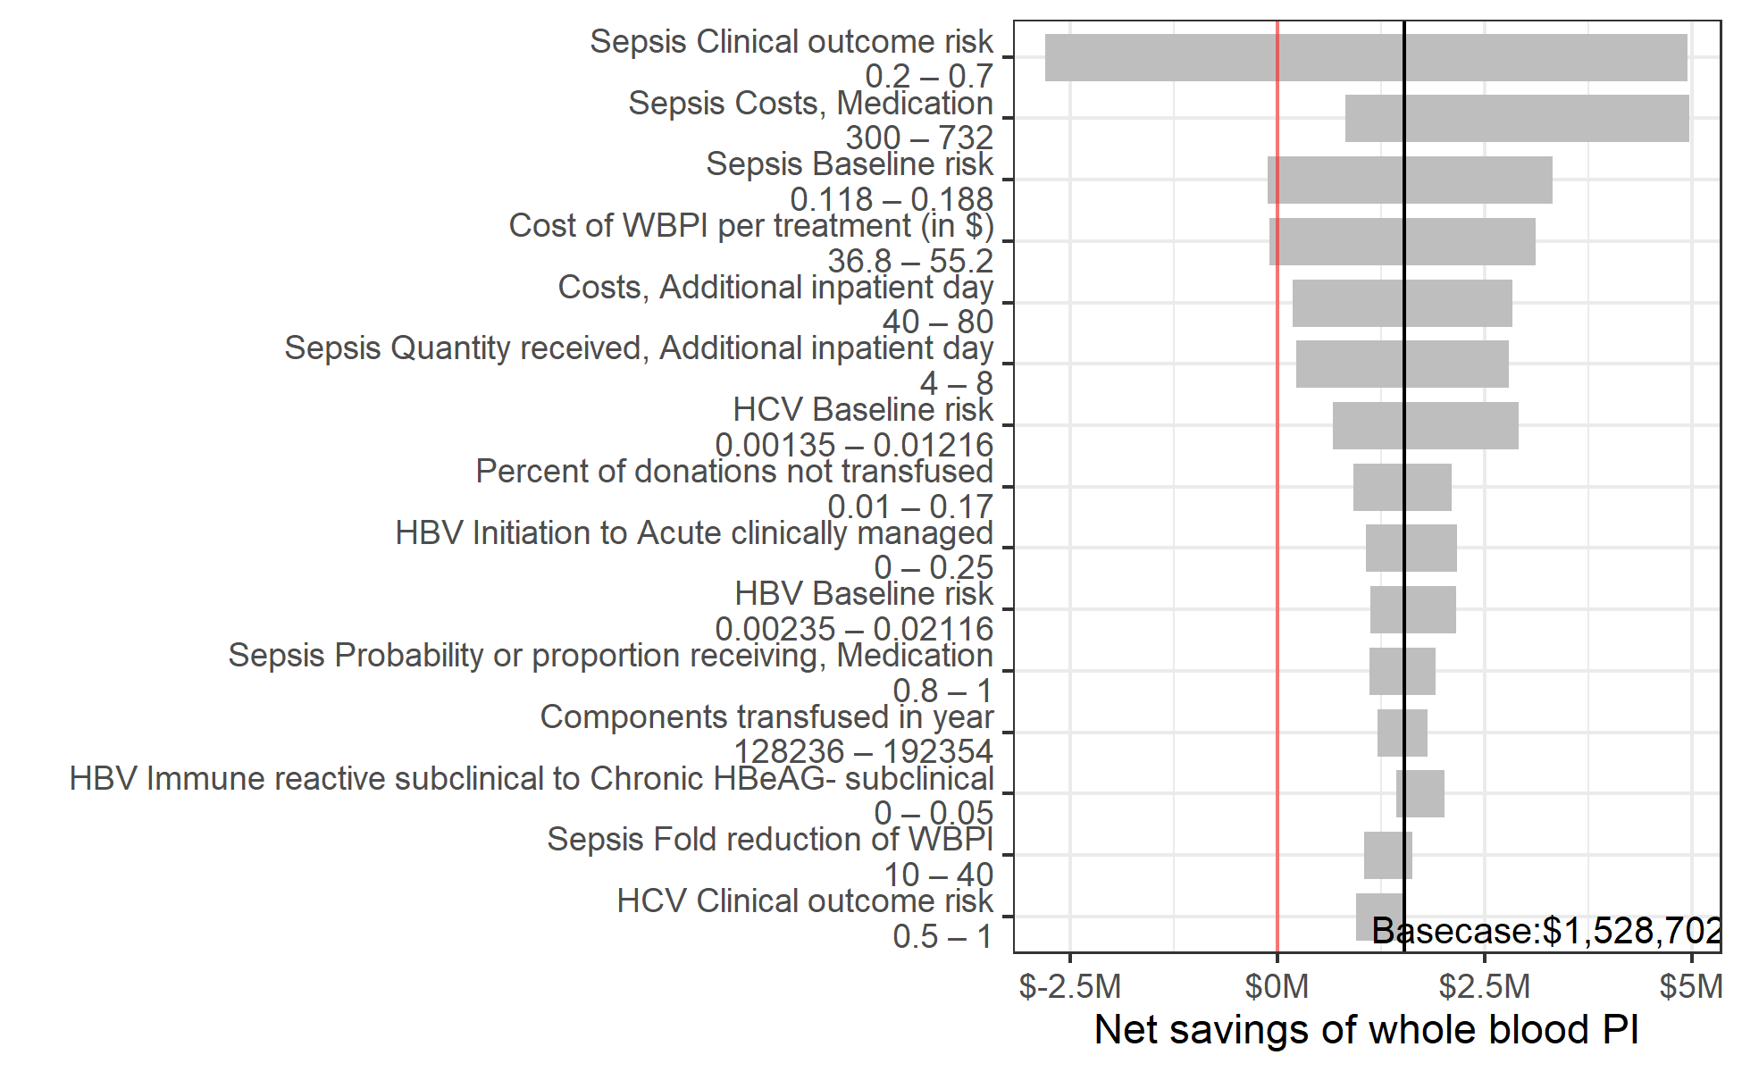

**Fig. 4.** Sensitivity of the net savings of pathogen inactivation to changes in the value of individual input parameters within prespecified uncertainty ranges. Y-axis shows all model parameters for which varying the value along the indicated range while keeping other parameters at their base case value led to a variation of more than $500,000 in the estimated net savings of whole blood pathogen inactivation.

##### 

# Supplemental materials

# A. Risk model calculations

The following equation was used to calculate the number of cases of each adverse event [AE], with and without WBPI:

$$\begin{matrix}(\text{[AE] Cases without WBPI})= & (\text{\#whole blood donations})× \\ & (\text{[AE] baseline risk})× \\ & (\text{[AE] clinical outcome risk})\end{matrix}$$

$$\begin{matrix}\text{[AE] Cases with WBPI}= & (\text{\#whole blood donations})× \\ & (\text{[AE] baseline risk})× \\ & (\text{[AE] clinical outcome risk})× \\ & (\text{[AE] transmissibility})\end{matrix}$$

The annual cost of WBPI was calculated as:

$$\begin{matrix}\text{WBPI cost per case}= & (\text{\#whole blood donations transfused})× \\ & (1+\text{\% donations not transfused})× \\ & (\text{PI cost per donation.})\end{matrix}$$

# B. Estimation of malaria clinical outcome risk

The risk of clinical malaria infection from the transfusion of a parasitaemic donation was calculated from data in Allain 2016 [12]. In that study, the prevalence of parasitemia was 23% (50/217) in recipients and 25% (91/367) in donors. Parasitemia by malaria species was also reported:

* In donors: 56 had *P falciparum* only; 4 had *P malariae* only; 1 had *P ovale* only; 26 had both *P falciparum* and *P malariae*; and 4 had all 3 species.
* In recipients: 48 had *P falciparum* only; 1 had *P malariae* only; 0 had *P ovale* only; 2 had both *P falciparum* and *P malariae*; and 0 had all 3 species.

From these numbers, we calculated the following probabilities:

* Probability donation has non-falciparum species given that it has malaria: 38.46%
* Probability donation has non-malariae species given that it has malaria: 62.64%
* Probability donation has non-ovale species given that it has malaria: 94.51%
* Probability donation has neither *P falciparum* nor *P malariae* given that it has malaria: 1.10%

From these, the probability that a parasitaemic recipient who is transfused with a parasitaemic donation would receive a species they are not already parasaetimic for was calculated by taking a sum of the probability donations do not have each set of malaria species weighted by the probability that recipients do have each set of malaria species. The result was 37.47%.

The probability of clinical outcomes when a malaria-positive donation is transfused to a non-parasitaemic recipient was reported as 21.6% (8 of 37 transfusions) with a 95% confidence interval of 9.8–38.2%. We assumed that when a parasitaemic donation is transfused to a parasitaemic recipient, the risk of transmission is the same as with a non-parasitaemic recipient when the donation contained a malaria species for which the recipient was not parasitaemic, and the risk of clinical outcomes was 0 when the recipient was already parasitaemic with all malaria species in the donation. Therefore, the estimated clinical outcome risk for a parasitaemic recipient was $21.60\%×37.47\%=8.09\%$. We then calculated the overall expected probability of transmission of a malaria parasitaemic donation by weighting the probability in parasitaemic recipients (8.09%) and the probability in non-parasitaemic recipients (21.60%) by the proportion of recipients who were parasitaemic (23%) for an overall risk of clinical outcomes of 18.5%. For the uncertainty range, we assumed the value could range from 45% to 176% of the base case value based on the range in the confidence interval around the risk of transmission from Allain 2016.

##### 

# Supplemental tables

**Table S1** Additional parameters used to calculate disability-adjusted life years (DALYs). These parameters were sampled from a PERT distribution in probabilistic sensitivity analysis.

| **Description** | **Value (range)** | **Source** |
| --- | --- | --- |
| **Sepsis DALY calculation parameters1** | | |
| Inpatient disability weight | 0.5 (0.4–0.6) | Custer 2010 |
| Probability of mortality due to sepsis | 19% (12%–29%) | Lewis 2019 |
| Probability of post-hospitalization sequelae | 15% (10%–20%) | Custer 2010 |
| Duration post-hospitalization sequelae (days) | 20 (14–30) | Assumed |
| Disability weight for post-hospitalization sequelae | 0.69 (0.59–0.79) | Custer 2010 |
| **FNHTR DALY calculation parameters** | | |
| Disability weight | 0.051 (0.032–0.074) | Assumed |
| Disability duration (days) | 14 (7–30) | Assumed |
| **Syphilis DALY calculation parameters** | | |
| Disability weight | 0.12 (0.09–0.15) | Custer 2010 |
| Disability duration (days) | 90 (60–180) | Assumed |
| **Malaria DALY calculation parameters** | | |
| Disability weight | 0.051 (0.032–0.074) | GBD 2013 |
| Disability duration (days) | 9 (7–20) | Assumed |
| Probability of mortality in pediatric cohort | 2.5% (0%–5%) | Assumed |
| **HCV disability weights2** | | |
| Acute subclinical | 0 (0–0) | Assumed |
| No infection | 0 (0–0) | Assumed |
| Acute on AVT | 0.04 (0–0.08) | Assumed |
| Chronic HCV subclinical | 0.21 (0.18–0.26) | Fraser 2016 |
| Chronic HCV on AVT | 0.25 (0.09–0.41) | Fraser 2016 |
| Chronic HCV treatment failure | 0.21 (0.18–0.26) | Fraser 2016 |
| Compensated cirrhosis subclinical | 0.252 (0.23–0.26) | Fraser 2016 |
| Compensated cirrhosis on AVT | 0.299 (0.15–0.45) | Fraser 2016 |
| Compensated cirrhosis treatment failure | 0.252 (0.23–0.26) | Fraser 2016 |
| Decompensated cirrhosis subclinical | 0.328 (0.31–0.4) | Fraser 2016 |
| Decompensated cirrhosis on AVT | 0.389 (0.368–0.475) | Fraser 2016 |
| Decompensated cirrhosis treatment failure | 0.328 (0.31–0.4) | Fraser 2016 |
| Hepatocellular carcinoma | 0.39 (0.33–0.8) | Fraser 2016 |
| **HBV disability weights3** | | |
| Chronic HBeAG- subclinical | 0.0265 (0–0.035) | Assumed |
| Chronic HBeAG- clinically managed | 0.0265 (0–0.035) | Assumed |
| Compensated cirrhosis subclinical | 0.252 (0.23–0.26) | Fraser 2016 |
| Decompensated cirrhosis subclinical | 0.328 (0.31–0.4) | Fraser 2016 |
| Hepatocellular carcinoma | 0.39 (0.33–0.8) | Fraser 2016 |
| Immune reactive on AVT | 0.053 (0.0424–0.0636) | Nayagam 2016 |
| Chronic HBeAG- on AVT | 0.053 (0.0424–0.0636) | Nayagam 2016 |
| Compensated cirrhosis on AVT | 0.053 (0.0424–0.0636) | Nayagam 2016 |
| Decompensated cirrhosis on AVT | 0.127 (0.102–0.152) | Nayagam 2016 |
| Acute subclinical | 0 (0–0) | Assumed |
| Acute clinically managed | 0 (0–0) | Assumed |
| No infection | 0 (0–0) | Assumed |
| Immune tolerant subclinical | 0 (0–0) | Assumed |
| Immune tolerant clinically managed | 0 (0–0) | Assumed |
| Carrier subclinical | 0 (0–0) | Assumed |
| Carrier clinically managed | 0 (0–0) | Assumed |
| Immune reactive subclinical | 0.053 (0–0.0636) | Nayagam 2016 |
| **HIV disability weights4** | | |
| HIV undetected year 1 | 0 (0–0) | Assumed |
| HIV undetected year 2 | 0 (0–0) | Assumed |
| HIV undetected year 3+ | 0 (0–0) | Assumed |
| AIDS undetected | 0.137 (0.092–0.188) | Assumed |
| AVT year 1 | 0.127 (0.085–0.178) | GBD 2013 |
| AVT year 2 | 0.078 (0.052–0.111) | GBD 2013 |
| AVT year 3 | 0.078 (0.052–0.111) | GBD 2013 |
| AVT year 4+ | 0.078 (0.052–0.111) | GBD 2013 |
| AIDS on AVT year 1 | 0.33 (0.229–0.427) | GBD 2013 |
| AIDS on AVT year 2 | 0.204 (0.14–0.269) | GBD 2013 |
| Residual disability from AIDS on AVT | 0.204 (0.14–0.269) | GBD 2013 |
| 1Sepsis: Inpatient mortality weight applied to the increased duration of hospitalization (parameter in Table S2. Probability of post-hospitalization sequelae appled to patients surviving hospitalization. | | |
| 2HCV: Assumed no disability from subclinical acute HCV. Assumed some disability from acute HCV on treatment due to side effects, calculated from the difference between the disability weights used for treatment at other disease stages. | | |
| 3HBV: Assumed no disability for acute, immune tolerant, and inactive carrier disease states. We assumed the disability in the chronic HBeAg- HBV would be half that of immune reactive when not on AVT and would be equal to that of immune reactive when on AVT. | | |
| 4HIV: We assumed no disability for undetected (subclinical) HIV. For undetected AIDS, we assumed patients experience symptoms that are less severe than average (otherwise they would be diagnosed), and we calculated their disability weight as 50% the typical disability weight for symptomatic pre-HIV AIDS. For patients initiating AVT with pre-AIDS HIV, we assume 50% had no symptoms and 50% have symptomatic HIV that typically becomes asymptomatic about 6 months after AVT initiation. We therefore calculated the average disability weight for the first year of HIV treatment as 75% of the 'receiving treatment' weight and 25% of the 'symptomatic HIV' weight. For patients initiating AVT with AIDS, we calculated their first-year disutility as 50% that of untreated AIDS and 50% that of a typical patient on treatment. We calculated their second-year disutility as 25% that of untreated AIDS and 75% that of a typical patient on treatment. For those with residual disability from their AIDS-related illness, we assumed their disutility remained the same for subsequent years on treatment. | | |

##### 

**Table S2** Parameters for the micro-costing calculations

| **Micro-costing parameters** | **Value (range); distribution** | **Source** |
| --- | --- | --- |
| **Probability or proportion receiving** | | |
| Inpatient mortality (no adverse event) | 0.072 (0.0576–0.0864); PERT | van Hulst 2008 |
| Acute adverse event costs incurred if inpatinet mortality | 0.45 (0.1–0.8); PERT | Estimated |
| Additional inpatient day, FNHTR | 0.5 (0.4–0.6); PERT | Estimated |
| Additional inpatient day, Malaria | 0.05 (0.01–0.09); PERT | Estimated |
| Outpatient clinic visit, Malaria | 0.5 (0.4–0.6); PERT | Estimated |
| Medication, Sepsis | 0.9 (0.8–1); PERT | Estimated |
| Diagnosis & treatment, Syphilis | 0.1 (0.05–0.2); PERT | Estimated |
| **Costs** | | |
| Additional inpatient day | 60 (40–80); PERT | Estimated |
| Liver function test | 13 (11–15); PERT | Estimated |
| International normalized ratio test | 7.7 (6.3–9); PERT | Estimated |
| Full blood count | 6.4 (5.5–7.3); PERT | Estimated |
| Blood urea nitrogen, creatinine, & electrolytes | 11.5 (10–13); PERT | Estimated |
| Alpha fetoprotein | 11.5 (11–12); PERT | Estimated |
| Brief outpatient visit | 6 (4–8); PERT | Estimated |
| Extensive outpatient visit | 12 (8–16); PERT | Estimated |
| Abdominal ultrasonography | 10 (8–12); PERT | Estimated |
| Endoscopy with band ligation | 272 (245–350); PERT | Estimated |
| Spironolactone | 350 (182–782); PERT | Estimated |
| Furosemide | 60.8 (55–66); PERT | Estimated |
| Transarterial chemoembolization | 1810 (1400–2200); PERT | Estimated |
| Triphasic CT scan | 173 (150–196); PERT | Estimated |
| Sorafenib (9-12 tablets) | 1920 (1640–2190); PERT | Estimated |
| Consultation and medication, FNHTR | 25 (20–30); PERT | Estimated |
| HBsAg test, HBV | 3.78 (2.16–5.4); PERT | Estimated |
| HBV profile test, HBV | 35.1 (21.6–48.6); PERT | Estimated |
| HBV DNA test, HBV | 73.8 (72–75.6); PERT | Estimated |
| AVT for non-cirrhotic patients, HBV | 326 (261–391); PERT | Estimated |
| AVT with cirrhosis, HBV | 869 (326–3590); PERT | Estimated |
| Ab screen and confirmation, HCV | 9 (7–13); PERT | Estimated |
| RNA test, HCV | 145 (120–170); PERT | Estimated |
| Genotyping, HCV | 163 (140–186); PERT | Estimated |
| Antiviral medication, HCV | 650 (548–1090); PERT | Estimated |
| AVT for decompensated cirrhosis, HCV | 1630 (1100–2170); PERT | Estimated |
| AIDS care first year on AVT, HIV | 585 (436–733); PERT | Estimated |
| AIDS care second year on AVT, HIV | 330 (266–393); PERT | Estimated |
| Residual disability from AIDS on AVT, HIV | 1150 (1000–1500); PERT | Estimated1 |
| Outpatient clinic visit, Malaria | 15 (10–20); PERT | Estimated1 |
| RDT + Microscopy, Malaria | 3 (1–5); PERT | Estimated |
| Medication, Malaria | 12 (4–20); PERT | Estimated |
| Medication, Sepsis | 372 (300–732); PERT | Estimated |
| Diagnosis, Syphilis | 15 (10–40); PERT | Estimated |
| Treatment, Syphilis | 12 (5–20); PERT | Estimated |
| AIDS care undetected, HIV | 150 (600–50); PERT | Mikkelsen 2017 |
| HIV care first year on AVT, HIV | 187 (149–224); PERT | Mikkelsen 2017 |
| HIV care second year on AVT, HIV | 64.5 (51.6–77.4); PERT | Mikkelsen 2017 |
| HIV care third year on AVT, HIV | 57 (45.6–68.4); PERT | Mikkelsen 2017 |
| HIV care annual cost after third year on AVT, HIV | 46.4 (37.1–55.6); PERT | Mikkelsen 2017 |
| **Quantity received** | | |
| Additional inpatient day, FNHTR | 2 (1–3); PERT | Estimated |
| Annual brief outpatient visits for chronic HBeAg-negative infection no AVT, HBV | 3 (2–4); PERT | Estimated |
| Annual brief outpatient visits for chronic HBeAg-negative infection with AVT, HBV | 1 (0–2); PERT | Estimated |
| Annual brief outpatient visits for compensated cirrhosis no AVT, HBV | 3 (2–4); PERT | Estimated |
| Annual brief outpatient visits for compensated cirrhosis with AVT, HBV | 3 (2–4); PERT | Estimated |
| Annual brief outpatient visits for decompensated cirrhosis no AVT, HBV | 4 (2–6); PERT | Estimated |
| Annual brief outpatient visits for decompensated cirrhosis with AVT, HBV | 4 (2–6); PERT | Estimated |
| Annual brief outpatient visits for acute infection with AVT, HCV | 3 (2–4); PERT | Estimated |
| Annual brief outpatient visits for chronic HCV without cirrhosis no AVT, HCV | 3 (2–4); PERT | Estimated |
| Annual brief outpatient visits for compensated cirrhosis no AVT, HCV | 4 (2–6); PERT | Estimated |
| Annual brief outpatient visits with decompensated cirrhosis no AVT, HCV | 4 (2–6); PERT | Estimated |
| Additional inpatient day, Malaria | 1.5 (1–2); PERT | Estimated |
| Outpatient clinic visit, Malaria | 1.2 (1–2); PERT | Estimated |
| Additional inpatient day, Sepsis | 6 (4–8); PERT | Estimated |
| 1We assumed patients who initiated AVT after AIDS progression were diagnosed based on symptoms and therefore incurred additional costs for due to AIDS-related illnesses. Costs in the first year were comprised of $57.80 for baseline laboratory investigations, $40.46 in follow-up visits, $255 - $510 for investigation and treatment for AIDS-related illnesses, and $83.04 -- $124.56 for AVT. Costs in the second year were the same, except we assumed only one third as much spending on investigation and treatment for AIDS-related illnesses. | | |

.

##### 

**Table S3** Annual transition probabilities used in the Markov models of chronic HIV, HBV, and HCV infections. Transitions indicated by `#` are calculated as one minus the probability of transitioning to any other state.

| **Annual transition probability** | | **Value (range); distribution** | **Source** |
| --- | --- | --- | --- |
| **From** | **To** |
| **HBV natural history** | | | |
| Acute subclinical | Immune tolerant subclinical | 95% (90%–99%); PERT | Mafirakureva 2016 |
| No infection | # |  |
| Acute clinically managed | Immune tolerant clinically managed | 95% (90%–99%); PERT | Mafirakureva 2016 |
| No infection | # |  |
| No infection | No infection | 100% |  |
| Immune tolerant subclinical | Immune reactive subclinical | 10% (3%–20%); β(5.063, 45.57) | Nayagam 2016 |
| Hepatocellular carcinoma | 0.3% (0%–0.6%); β(3.985, 1324.35) | Nayagam 2016 |
| Immune tolerant subclinical | # |  |
| Immune tolerant clinically managed | Immune reactive on AVT | 10% (3%–20%); β(5.063, 45.57) | Nayagam 2016 |
| Immune tolerant clinically managed | # |  |
| Carrier subclinical | Chronic HBeAG- subclinical | 2.68% (1.55%–4.71%); β(11.173, 405.74) | Nayagam 2016 |
| Hepatocellular carcinoma | 0.065% (0%–0.1%); β(0.057, 94.89) | Nayagam 2016 |
| No infection | 1% (0.97%–2.26%); β(17.146, 1257.65) | Nayagam 2016 |
| Carrier subclinical | # |  |
| Carrier clinically managed | Chronic HBeAG- clinically managed | 2.68% (1.55%–4.71%); β(11.173, 405.74) | Nayagam 2016 |
| No infection | 1% (0.97%–2.26%); β(17.146, 1257.65) | Nayagam 2016 |
| Carrier clinically managed | # |  |
| Immune reactive subclinical | Chronic HBeAG- subclinical | 0.5% (0%–5%); β(0.154, 30.69) | Nayagam 2016 |
| Carrier subclinical | 5.74% (4.58%–6.88%); β(11.971, 196.76) | Nayagam 2016 |
| Hepatocellular carcinoma | 0.65% (0.27%–1%); β(12.596, 1925.3) | Nayagam 2016 |
| Immune reactive subclinical | # |  |
| Chronic HBeAG- subclinical | Compensated cirrhosis subclinical | 4% (1%–5.2%); β(11.173, 300.92) | Nayagam 2016 |
| Hepatocellular carcinoma | 0.616% (0.27%–1%); β(11.3, 1824.5) | Nayagam 2016 |
| Chronic HBeAG- subclinical | # |  |
| Chronic HBeAG- clinically managed | Compensated cirrhosis on AVT | 4% (1%–5.2%); β(11.173, 300.92) | Nayagam 2016 |
| Hepatocellular carcinoma | 0.616% (0.27%–1%); β(11.3, 1824.5) | Nayagam 2016 |
| Chronic HBeAG- clinically managed | # |  |
| Compensated cirrhosis subclinical | Decompensated cirrhosis subclinical | 3.9% (3.2%–4.6%); β(2.848, 70.18) | Nayagam 2016 |
| Hepatocellular carcinoma | 3.66% (0.8%–8%); β(3.947, 103.88) | Nayagam 2016 |
| HBV-related death | 3.9% (3.9%–50.7%); β(0.27, 6.66) | Nayagam 2016 |
| Compensated cirrhosis subclinical | # |  |
| Decompensated cirrhosis subclinical | Hepatocellular carcinoma | 3.76% (2.3%–7.1%); β(9.411, 240.88) | Nayagam 2016 |
| HBV-related death | 31.4% (4.3%–57%); β(3.583, 7.83) | Nayagam 2016 |
| Decompensated cirrhosis subclinical | # |  |
| Hepatocellular carcinoma | HBV-related death | 50% (40%–100%); β(5.056, 5.06) | Nayagam 2016 |
| Hepatocellular carcinoma | # |  |
| HBV-related death | HBV-related death | 100% | Nayagam 2016 |
| **HBV treatment effectiveness** | | | |
| Immune reactive on AVT | Immune reactive on AVT | 100% | Nayagam 2016 |
| Chronic HBeAG- on AVT | Chronic HBeAG- on AVT | 100% | Nayagam 2016 |
| Compensated cirrhosis on AVT | Hepatocellular carcinoma | 0.5% (0%–1%); β(0.747, 149) | Nayagam 2016 |
| Compensated cirrhosis on AVT | # |  |
| Decompensated cirrhosis on AVT | Hepatocellular carcinoma | 1% (0%–4.4%); β(0.808, 80) | Nayagam 2016 |
| Decompensated cirrhosis on AVT | # |  |
| **HBV treatment uptake** | | | |
| Initiation | Acute clinically managed | 10% (0%–25%); PERT | Estimated |
| Acute subclinical | # |  |
| Chronic HBeAG- subclinical | Chronic HBeAG- clinically managed | 5% (1%–20%); PERT | Estimated |
| Chronic HBeAG- clinically managed | Chronic HBeAG- on AVT | 9% (4%–18%); PERT | Estimated |
| Compensated cirrhosis subclinical | Compensated cirrhosis on AVT | 30% (10%–40%); PERT | Estimated |
| Decompensated cirrhosis subclinical | Decompensated cirrhosis on AVT | 70% (50%–90%); PERT | Estimated |
| **HCV natural history** | | | |
| Acute subclinical | No infection | 31% (15%–40%); PERT | Mafirakureva 2016 |
| Chronic HCV subclinical | # |  |
| No infection | No infection | 100% |  |
| Chronic HCV subclinical | Compensated cirrhosis subclinical | 1.1% (0.5%–1.8%); PERT | Fraser 2016 |
| Chronic HCV subclinical | # |  |
| Chronic HCV treatment failure | Compensated cirrhosis treatment failure | 1.1% (0.5%–1.8%); PERT | Fraser 2016 |
| Chronic HCV treatment failure | # |  |
| Compensated cirrhosis subclinical | Decompensated cirrhosis subclinical | 6.4% (3%–7%); PERT | Fraser 2016 |
| Hepatocellular carcinoma | 3.6% (1.5%–4%); PERT | Fraser 2016 |
| Compensated cirrhosis subclinical | # |  |
| Compensated cirrhosis treatment failure | Decompensated cirrhosis treatment failure | 6.4% (3%–7%); PERT | Fraser 2016 |
| Hepatocellular carcinoma | 3.6% (1.5%–4%); PERT | Fraser 2016 |
| Compensated cirrhosis treatment failure | # |  |
| Decompensated cirrhosis subclinical | Hepatocellular carcinoma | 6.8% (4.1%–9.9%); PERT | Fraser 2016 |
| HCV-related death | 16.8% (12%–40%); PERT | Fraser 2016 |
| Decompensated cirrhosis subclinical | # |  |
| Decompensated cirrhosis treatment failure | Hepatocellular carcinoma | 6.8% (4.1%–9.9%); PERT | Fraser 2016 |
| HCV-related death | 16.8% (12%–40%); PERT | Fraser 2016 |
| Decompensated cirrhosis treatment failure | # |  |
| Hepatocellular carcinoma | HCV-related death | 60.5% (30%–80%); PERT | Fraser 2016 |
| Hepatocellular carcinoma | # |  |
| HCV-related death | HCV-related death | 100% | Fraser 2016 |
| **HCV treatment effectiveness** | | | |
| Acute on AVT | No infection* | 95% (90%–99%); PERT | Fraser 2016 |
| Chronic HCV treatment failure | # |  |
| Chronic HCV on AVT | No infection | 95% (90%–99%); PERT | Fraser 2016 |
| Chronic HCV treatment failure | # |  |
| Compensated cirrhosis on AVT | No infection | 95% (90%–99%); PERT | Fraser 2016 |
| Compensated cirrhosis treatment failure | # |  |
| Decompensated cirrhosis on AVT | No infection | 95% (90%–99%); PERT | Fraser 2016 |
| Decompensated cirrhosis treatment failure | # |  |
| **HCV treatment uptake** | | | |
| Initiation | Acute on AVT | 10% (0%–25%); PERT | Estimated |
| Acute subclinical | # |  |
| Chronic HCV subclinical | Chronic HCV on AVT | 10% (5%–30%); PERT | Estimated |
| Compensated cirrhosis subclinical | Compensated cirrhosis on AVT | 30% (10%–40%); PERT | Estimated |
| Decompensated cirrhosis subclinical | Decompensated cirrhosis on AVT | 70% (50%–90%); PERT | Estimated |
| **HIV natural history** | | | |
| HIV subclinical 1st year | HIV subclinical 2nd year | 100% |  |
| HIV subclinical 2nd year | HIV subclinical 3+ years | 100% |  |
| HIV subclinical 3+ years | AIDS (pediatric) | 4.21% (3.07%–5.62%); PERT | Morgan 2002 |
| AIDS (adult) | 15% (10.1%–22.6%); PERT | Morgan 2002 |
| HIV-related death (pediatric) | 1.5% (0%–6.9%); PERT | Morgan 2002 |
| HIV-related death (adult) | 0% (0%–5.5%); PERT | Morgan 2002 |
| HIV subclinical 3+ years | # |  |
| AIDS subclinical | HIV-related death (pediatric) | 60.2% (32.4%–70%); PERT | Morgan 2002 |
| HIV-related death (adult) | 61.5% (28.6%–70%); PERT | Morgan 2002 |
| AIDS subclinical | # |  |
| HIV-related death | HIV-related death | 100% | Morgan 2002 |
| **HIV treatment uptake** | | | |
| Initiation | AVT year 1 | 7.5% (0%–15%); PERT | Estimated |
| HIV subclinical year 1 | # |  |
| HIV subclinical year 1 | AVT year 1 | 7.1% (0%–13%); PERT | Estimated |
| HIV subclinical year 2 | AVT year 1 | 18.6% (7%–31%); PERT | Estimated |
| HIV subclinical year 3+ | AVT year 1 | 30% (14%–47%); PERT | Estimated |
| AIDS subclinical | AIDS on AVT year 1 | 50% (30%–70%); PERT | Estimated |
| **HIV treatment effectiveness** | | | |
| AVT year 1 | AVT year 2 | 100% | Assumed |
| AVT year 2 | AVT year 3 | 100% | Assumed |
| AVT year 3 | AVT year 4+ | 100% | Assumed |
| AVT year 4+ | AVT year 4+ | 100% | Assumed |
| AIDS on AVT year 1 | HIV-related death | 30% (15%–40%); PERT | Estimated |
| AIDS on AVT year 2 | # |  |
| AIDS on AVT year 2 | HIV-related death | 15% (0%–30%); PERT | Estimated |
| Residual disability on AVT | 35% (15%–55%); PERT | Estimated |
| AVT year 3 | # |  |
| Residual disability from AIDS on AVT | HIV-related death | 15% (0%–30%); PERT | Estimated |
| Residual disability from AIDS on AVT | # |  |

##### 

**Table S4** Calculations used for each disease state (acute illness for sepsis, malaria, febrile non-hemolytic transfusion reactions, and syphilis; annual costs for each disease state in the HBV and HIV Markov models)

| **Disease state** | **Microcosting calculation** |
| --- | --- |
| Sepsis | (cost × quantity) additional inpatient days +  (proportion × cost) medication |
| Malaria | (cost × quantity × proportion) additional inpatient days +  (cost × quantity × proportion) outpatient clinic visits +  (cost) diagnosis +  (cost) medication |
| FNHTR | (cost) medication and consult +  (cost × quantity × proportion) additional inpatient days |
| Syphilis | (cost × proportion) diagnosis +  (cost × proportion) medications |
| HBV acute clinically managed | (2 × cost) HBsAg test +  (cost) HBV profile +  (cost) HBV DNA test +  (cost) extensive outpatient clinic visit +  (cost) brief outpatient clinic visit |
| HBV acute subclinical | 0 |
| HBV no infection | 0 |
| HBV immune tolerant clinically managed | (cost) extensive outpatient clinic visit +  (cost) HBsAg test +  (cost) HBV profile +  (cost) HBV DNA test +  (cost) liver function test |
| HBV immune tolerant subclinical | 0 |
| HBV carrier subclinical | 0 |
| HBV carrier clinically managed | 0 |
| HBV immune reactive on AVT | cost) extensive outpatient clinic visit +  (cost) HBsAg test +  (cost) HBV profile +  (cost) HBV DNA test +  (cost) liver function test +  (cost) HBV antivirals for non-cirrhotic patients |
| HBV immune reactive subclinical | 0 |
| HBV chronic HBeAg- on AVT | (cost) liver function test +  (cost) HBV profile +  (cost) HBV DNA test +  (cost) blood urea nitrogen, creatinine, & electrolytes +  (cost) full blood count +  (cost) alpha fetoprotein test +  (cost) abdominal ultrasonography +  (cost × quantity) brief outpatient visit +  (cost) HBV antivirals for non-cirrhotic patients |
| HBV chronic HBeAg- clinically managed | (cost) liver function test +  (cost) HBV profile +  (cost) HBV DNA test +  (cost) blood urea nitrogen, creatinine, & electrolytes +  (cost) full blood count +  (cost) alpha fetoprotein test +  (cost) abdominal ultrasonography +  (cost × quantity) brief outpatient visit |
| HBV chronic HBeAg- subclinical | 0 |
| HBV compensated cirrhosis on AVT | (cost) liver function test +  (cost) international normalized ratio test +  (2 × cost) HBV DNA test +  (cost) blood urea nitrogen, creatinine, & electrolytes +  (cost) full blood count +  (2 × cost) alpha fetoprotein test +  (2 × cost) abdominal ultrasonography +  (cost × quantity) brief outpatient visit |
| HBV compensated cirrhosis subclinical | 0 |
| HBV decompensated cirrhosis on AVT | (cost) liver function test +  (cost) international normalized ratio test +  (2 × cost) HBV DNA test +  (cost) blood urea nitrogen, creatinine, & electrolytes +  (cost) full blood count +  (2 × cost) alpha fetoprotein test +  (2 × cost) abdominal ultrasonography +  (cost × quantity) brief outpatient visit +  (cost) HBV antivirals for patients with cirrhosis |
| HBV decompensated cirrhosis subclinical | 0 |
| HBV hepatocellular carcinoma | (cost) liver function test +  (cost) international normalized ratio test +  (cost) Full blood count +  (cost) alpha fetoprotein test +  (cost) triphasic CT scan +  (cost) endoscopy with band ligation +  (cost) sorafenib +  (cost) transAVTerial chemoembolization |
| HBV related death or other-cause death | 0 |
| HCV acute subclinical | 0 |
| HCV acute with AVT | (cost) Ab screen and confirmation +  (2 × cost) HCV RNA test +  (cost) HCV genotyping +  (cost) liver function test +  (cost) Blood urea nitrogen, creatinine, & electrolytes +  (cost × quantity) brief outpatient visit +  (cost) HCV antivirals |
| HCV no infection | 0 |
| HCV chronic subclinical | 0 |
| HCV chronic with AVT | (cost) liver function test +  (cost) Blood urea nitrogen, creatinine, & electrolytes +  (cost) Full blood count +  (cost) alpha fetoprotein test +  (cost) abdominal ultrasonography +  (cost) HCV genotyping +  (2 × cost) HCV RNA test +  (cost × quantity) brief outpatient visit  (cost) HCV antivirals |
| HCV chronic treatment failure | (cost) liver function test +  (cost) Blood urea nitrogen, creatinine, & electrolytes +  (cost) Full blood count +  (cost) alpha fetoprotein test +  (cost) abdominal ultrasonography +  (cost) HCV genotyping +  (2 × cost) HCV RNA test +  (cost × quantity) brief outpatient visit |
| HCV compensated cirrhosis subclinical | 0 |
| HCV compensated cirrhosis with AVT | (cost) liver function test +  (cost) international normalized ratio test +  (cost) Blood urea nitrogen, creatinine, & electrolytes +  (cost) Full blood count +  (2 × cost) alpha fetoprotein test +  (2 × cost) abdominal ultrasonography +  (cost) HCV genotyping +  (2 × cost) HCV RNA test +  (cost × quantity) brief outpatient visit  (cost) HCV antivirals |
| HCV compensated cirrhosis treatment failure | (cost) liver function test +  (cost) international normalized ratio test +  (cost) Blood urea nitrogen, creatinine, & electrolytes +  (cost) Full blood count +  (2 × cost) alpha fetoprotein test +  (2 × cost) abdominal ultrasonography +  (cost) HCV genotyping +  (2 × cost) HCV RNA test +  (cost × quantity) brief outpatient visit |
| HCV decompensated cirrhosis subclinical | 0 |
| HCV decompensated cirrhosis with AVT | (cost) liver function test +  (cost) international normalized ratio test +  (cost) Blood urea nitrogen, creatinine, & electrolytes +  (cost) Full blood count +  (2 × cost) alpha fetoprotein test +  (2 × cost) abdominal ultrasonography +  (cost) HCV genotyping +  (3 × cost) HCV RNA test +  (2 × cost) endoscopy with band ligation +  (cost) spironolactone +  (cost) furosemide +  (cost × quantity) brief outpatient visit  (cost) HCV antivirals |
| HCV decompensated cirrhosis treatment failure | (cost) liver function test +  (cost) international normalized ratio test +  (cost) Blood urea nitrogen, creatinine, & electrolytes +  (cost) Full blood count +  (2 × cost) alpha fetoprotein test +  (2 × cost) abdominal ultrasonography +  (cost) HCV genotyping +  (3 × cost) HCV RNA test +  (2 × cost) endoscopy with band ligation +  (cost) spironolactone +  (cost) furosemide +  (cost × quantity) brief outpatient visit |
| HCV hepatocellular carcinoma | (cost) liver function test +  (cost) international normalized ratio test +  (cost) Full blood count +  (cost) alpha fetoprotein test +  (cost) triphasic CT scan +  (cost) endoscopy with band ligation +  (cost) sorafenib +  (cost) transAVTerial chemoembolization |
| HCV related death or other-cause death | 0 |
| AVT initiation with AIDS | (cost) AVT costs (year 1) +  (cost) treatment of AIDS-related illness |
| Second year on AVT with AIDS | (cost) AVT costs (year 2) +  (cost) treatment of AIDS-related illness |
| Residual disability from AIDS on AVT | (cost) AVT costs (year 4+) +  (cost) treatment of residual disability |

##### 

**Table S5** Calculated annual costs for each disease state in the HIV, HBV, and HCV disease progression Markov models

| **Disease state** | **Annual cost** | **Undiscounted Lifetime cost, Adult** | **Undiscounted Lifetime cost, Pediatric** | **Net present lifetime cost, Adult** | **Net present lifetime cost, Pediatric** |
| --- | --- | --- | --- | --- | --- |
| HBV | | | | | |
| Acute clinically managed | $134.46 | $6.72 | $6.72 | $6.72 | $6.72 |
| Acute subclinical | $0.00 | $0.00 | $0.00 | $0.00 | $0.00 |
| Carrier clinically managed | $0.00 | $0.00 | $0.00 | $0.00 | $0.00 |
| Carrier subclinical | $0.00 | $0.00 | $0.00 | $0.00 | $0.00 |
| Chronic HBeAG- clinically managed | $179.30 | $52.75 | $202.36 | $23.71 | $60.92 |
| Chronic HBeAG- on AVT | $493.23 | $122.62 | $1,148.44 | $48.69 | $257.31 |
| Chronic HBeAG- subclinical | $0.00 | $0.00 | $0.00 | $0.00 | $0.00 |
| Compensated cirrhosis on AVT | $1,116.34 | $445.53 | $3,504.13 | $181.25 | $822.75 |
| Compensated cirrhosis subclinical | $0.00 | $0.00 | $0.00 | $0.00 | $0.00 |
| Decompensated cirrhosis on AVT | $2,076.14 | $42.51 | $328.39 | $17.19 | $77.65 |
| Decompensated cirrhosis subclinical | $0.00 | $0.00 | $0.00 | $0.00 | $0.00 |
| HBV-related death | $0.00 | $0.00 | $0.00 | $0.00 | $0.00 |
| Hepatocellular carcinoma | $4,210.60 | $726.90 | $1,287.79 | $454.78 | $621.00 |
| Immune reactive on AVT | $463.61 | $913.57 | $2,228.22 | $511.88 | $857.42 |
| Immune reactive subclinical | $0.00 | $0.00 | $0.00 | $0.00 | $0.00 |
| Immune tolerant clinically managed | $137.68 | $117.46 | $127.98 | $94.82 | $100.56 |
| Immune tolerant subclinical | $0.00 | $0.00 | $0.00 | $0.00 | $0.00 |
| No infection | $0.00 | $0.00 | $0.00 | $0.00 | $0.00 |
| Other-cause death | $0.00 | $0.00 | $0.00 | $0.00 | $0.00 |
| HCV | | | | | |
| Acute on AVT | $1,154.50 | $57.72 | $57.72 | $57.72 | $57.72 |
| Acute subclinical | $0.00 | $0.00 | $0.00 | $0.00 | $0.00 |
| Chronic HCV on AVT | $1,173.40 | $597.84 | $649.35 | $475.74 | $505.23 |
| Chronic HCV subclinical | $0.00 | $0.00 | $0.00 | $0.00 | $0.00 |
| Chronic HCV treatment failure | $523.40 | $307.64 | $635.48 | $178.68 | $271.34 |
| Compensated cirrhosis on AVT | $1,208.60 | $47.73 | $53.37 | $35.35 | $38.45 |
| Compensated cirrhosis subclinical | $0.00 | $0.00 | $0.00 | $0.00 | $0.00 |
| Compensated cirrhosis treatment failure | $558.60 | $32.76 | $74.90 | $17.77 | $29.44 |
| Decompensated cirrhosis on AVT | $3,291.40 | $17.31 | $19.65 | $12.37 | $13.63 |
| Decompensated cirrhosis subclinical | $0.00 | $0.00 | $0.00 | $0.00 | $0.00 |
| Decompensated cirrhosis treatment failure | $1,657.40 | $23.38 | $58.12 | $12.11 | $21.55 |
| HCV-related death | $0.00 | $0.00 | $0.00 | $0.00 | $0.00 |
| Hepatocellular carcinoma | $4,210.60 | $43.72 | $75.79 | $27.66 | $37.23 |
| No infection | $0.00 | $0.00 | $0.00 | $0.00 | $0.00 |
| Other-cause death | $0.00 | $0.00 | $0.00 | $0.00 | $0.00 |
| HIV | | | | | |
| AIDS on ART year 1 | $771.26 | $83.21 | $28.89 | $71.53 | $24.48 |
| AIDS on ART year 2 | $394.08 | $29.52 | $10.32 | $24.64 | $8.49 |
| ART year 1 | $186.70 | $142.47 | $163.19 | $130.83 | $147.95 |
| ART year 2 | $64.52 | $51.29 | $58.72 | $45.99 | $51.97 |
| ART year 3 | $57.02 | $47.09 | $52.56 | $40.87 | $45.12 |
| ART year 4+ | $46.35 | $972.20 | $2,357.82 | $558.79 | $947.85 |
| HIV-related death | $0.00 | $0.00 | $0.00 | $0.00 | $0.00 |
| Other-cause death | $0.00 | $0.00 | $0.00 | $0.00 | $0.00 |
| Residual disability from AIDS on AVT | $1,196.35 | $192.38 | $72.04 | $136.17 | $49.56 |
| Subclinical AIDS | $150.00 | $32.61 | $11.25 | $28.88 | $9.82 |
| Subclinical HIV year 1 | $0.00 | $0.00 | $0.00 | $0.00 | $0.00 |
| Subclinical HIV year 2 | $0.00 | $0.00 | $0.00 | $0.00 | $0.00 |
| Subclinical HIV year 3+ | $0.00 | $0.00 | $0.00 | $0.00 | $0.00 |

# Supplemental figures

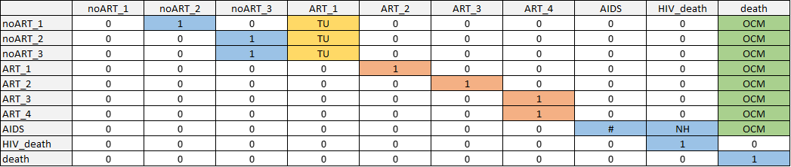

**Fig. S1.** Transition matrix schematic for HIV. Non-zero transition probabilities are indicated in blue for natural history transitions, yellow for treatment uptake transitions, orange for treatment effectiveness transitions, and green for other-cause mortality. Markov model constructed by first creating a transition matrix without treatment uptake or other-cause death; then adding in treatment uptake transitions while scaling other transitions such that each row still sums to 1; then adding in transitions to other-cause mortality with the same approach. Disease state names: AIDS_SC, Subclinical AIDS; ART_1, ART year 1; ART_2, ART year 2; ART_3, ART year 3; ART_4, ART year 4+; HIV_death, HIV-related death; HIV_SC_1, Subclinical HIV year 1; HIV_SC_2, Subclinical HIV year 2; HIV_SC_3, Subclinical HIV year 3+; AIDS_ART_1, AIDS on ART year 1; AIDS_ART_2, AIDS on ART year 2; AIDS_RD, Residual disability from AIDS on AVT; death, Other-cause death. Abbreviations: NH, natural history (blue); TU, treatment uptake (marigold); TE, treatment effectiveness (orange); OCM, other cause mortality (green)

##### 

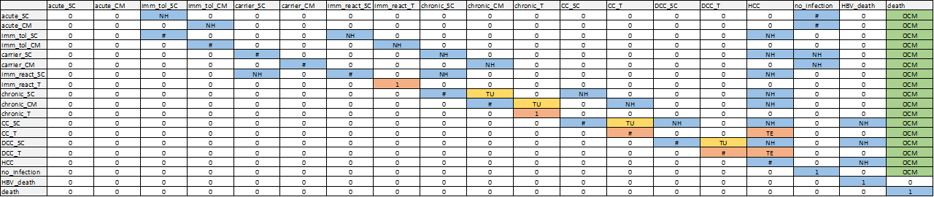

**Fig. S2.** Transition matrix schematic for HBV. Non-zero transition probabilities are indicated in blue for natural history transitions, yellow for treatment uptake transitions, orange for treatment effectiveness transitions, and green for other-cause mortality. Markov model constructed by first creating a transition matrix without treatment uptake or other-cause death; then adding in treatment uptake transitions while scaling other transitions such that each row still sums to 1; then adding in transitions to other-cause mortality with the same approach. Disease state names: acute_CM, Acute clinically managed; acute_SC, Acute subclinical; carrier_CM, Carrier clinically managed; carrier_SC, Carrier subclinical; CC_SC, Compensated cirrhosis subclinical; CC_T, Compensated cirrhosis on AVT; chronic_CM, Chronic HBeAG- clinically managed; chronic_SC, Chronic HBeAG- subclinical; chronic_T, Chronic HBeAG- on AVT; DCC_SC, Decompensated cirrhosis subclinical; DCC_T, Decompensated cirrhosis on AVT; HBV_death, HBV-related death; HCC, Hepatocellular carcinoma; imm_react_SC, Immune reactive subclinical; imm_react_T, Immune reactive on AVT; imm_tol_CM, Immune tolerant clinically managed; imm_tol_SC, Immune tolerant subclinical; init, Initiation; no_infection, No infection; death, Other-cause death. Abbreviations: NH, natural history (blue); TU, treatment uptake (marigold); TE, treatment effectiveness (orange); OCM, other cause mortality (green)

##### 

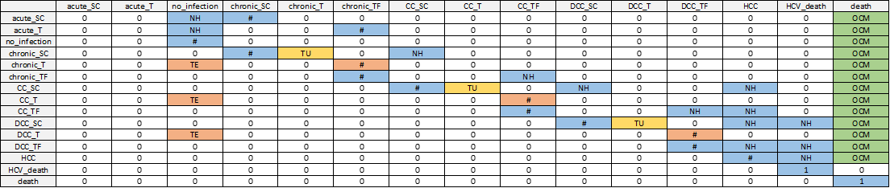

**Fig. S3.** Transition matrix schematic for HCV. Non-zero transition probabilities are indicated in blue for natural history transitions, yellow for treatment uptake transitions, orange for treatment effectiveness transitions, and green for other-cause mortality. Markov model constructed by first creating a transition matrix without treatment uptake or other-cause death; then adding in treatment uptake transitions while scaling other transitions such that each row still sums to 1; then adding in transitions to other-cause mortality with the same approach. Disease state names: acute_SC, Acute subclinical; acute_T, Acute on AVT; CC_SC, Compensated cirrhosis subclinical; CC_T, Compensated cirrhosis on AVT; CC_TF, Compensated cirrhosis treatment failure; chronic_SC, Chronic HCV subclinical; chronic_T, Chronic HCV on AVT; chronic_TF, Chronic HCV treatment failure; DCC_SC, Decompensated cirrhosis subclinical; DCC_T, Decompensated cirrhosis on AVT; DCC_TF, Decompensated cirrhosis treatment failure; HCC, Hepatocellular carcinoma; HCV_death, HCV-related death; init, Initiation; no_infection, No infection; death, Other-cause death. Abbreviations: NH, natural history (blue); TU, treatment uptake (marigold); TE, treatment effectiveness (orange); OCM, other cause mortality (green)

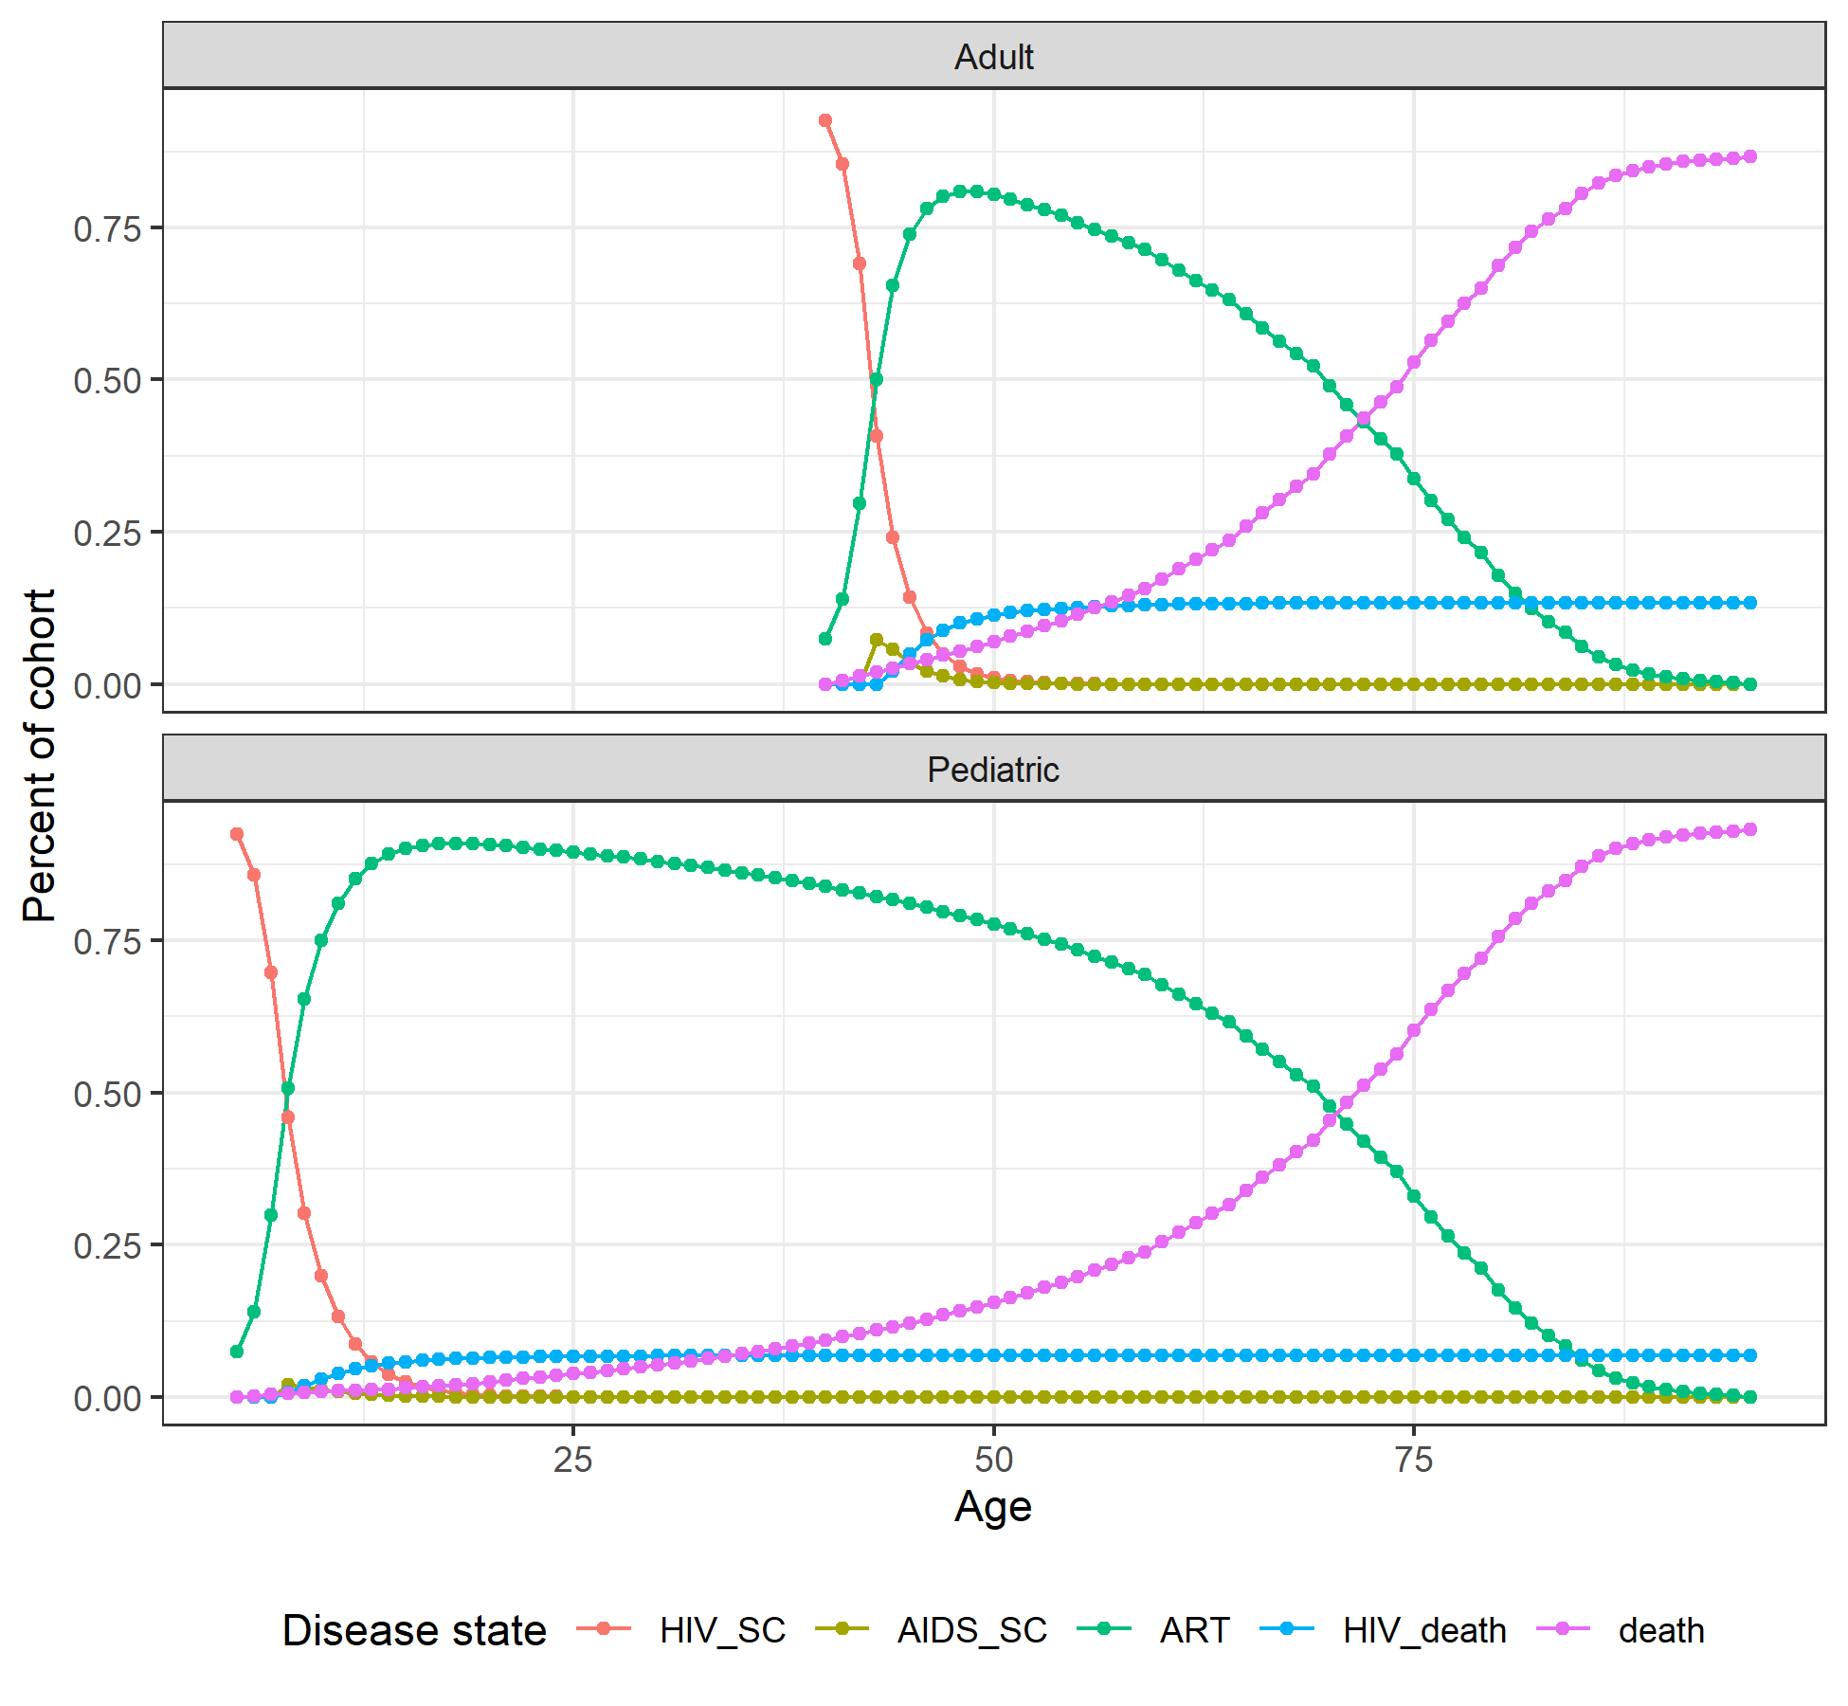

**Fig. S4.** Markov trace plot for HIV pediatric and adult cohorts. Disease state names: AIDS_SC, Subclinical AIDS; ART_1, ART year 1; ART_2, ART year 2; ART_3, ART year 3; ART_4, ART year 4+; HIV_death, HIV-related death; HIV_SC_1, Subclinical HIV year 1; HIV_SC_2, Subclinical HIV year 2; HIV_SC_3, Subclinical HIV year 3+; AIDS_ART_1, AIDS on ART year 1; AIDS_ART_2, AIDS on ART year 2; AIDS_RD, Residual disability from AIDS on AVT; death, Other-cause death.

##### 

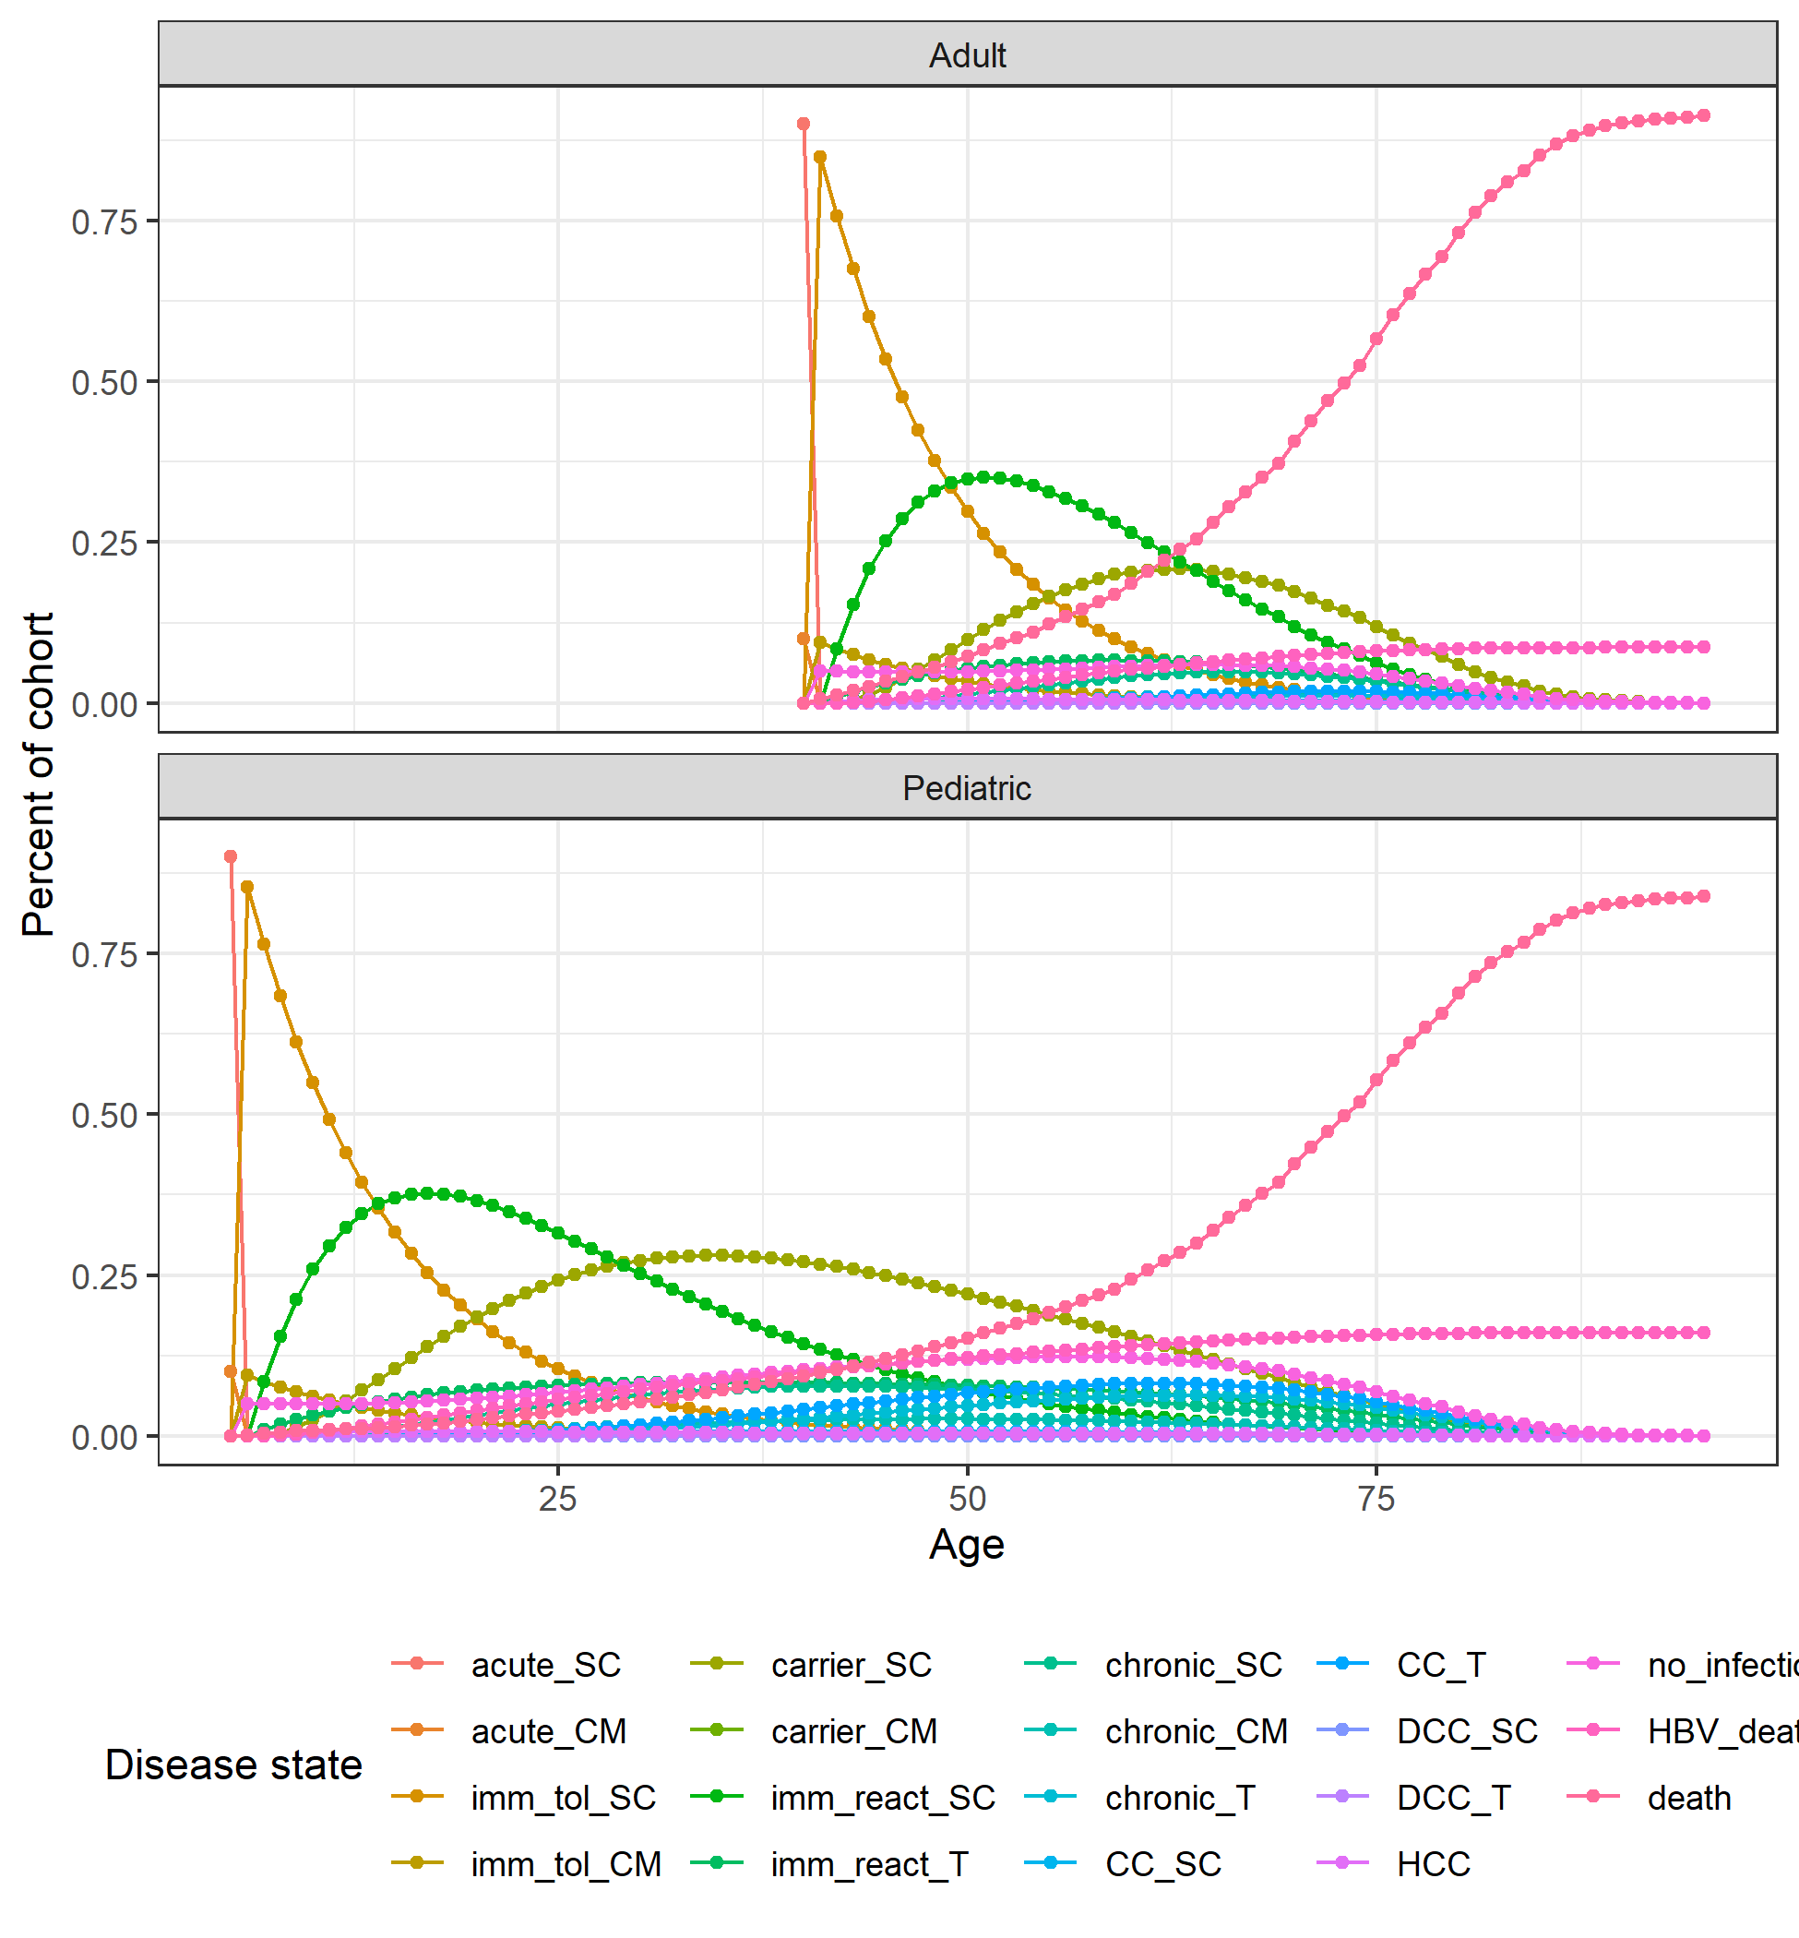

**Fig. S5.** Markov trace plot for HBV pediatric and adult cohorts. Disease state names: acute_CM, Acute clinically managed; acute_SC, Acute subclinical; carrier_CM, Carrier clinically managed; carrier_SC, Carrier subclinical; CC_SC, Compensated cirrhosis subclinical; CC_T, Compensated cirrhosis on AVT; chronic_CM, Chronic HBeAG- clinically managed; chronic_SC, Chronic HBeAG- subclinical; chronic_T, Chronic HBeAG- on AVT; DCC_SC, Decompensated cirrhosis subclinical; DCC_T, Decompensated cirrhosis on AVT; HBV_death, HBV-related death; HCC, Hepatocellular carcinoma; imm_react_SC, Immune reactive subclinical; imm_react_T, Immune reactive on AVT; imm_tol_CM, Immune tolerant clinically managed; imm_tol_SC, Immune tolerant subclinical; init, Initiation; no_infection, No infection; death, Other-cause death.

##### 

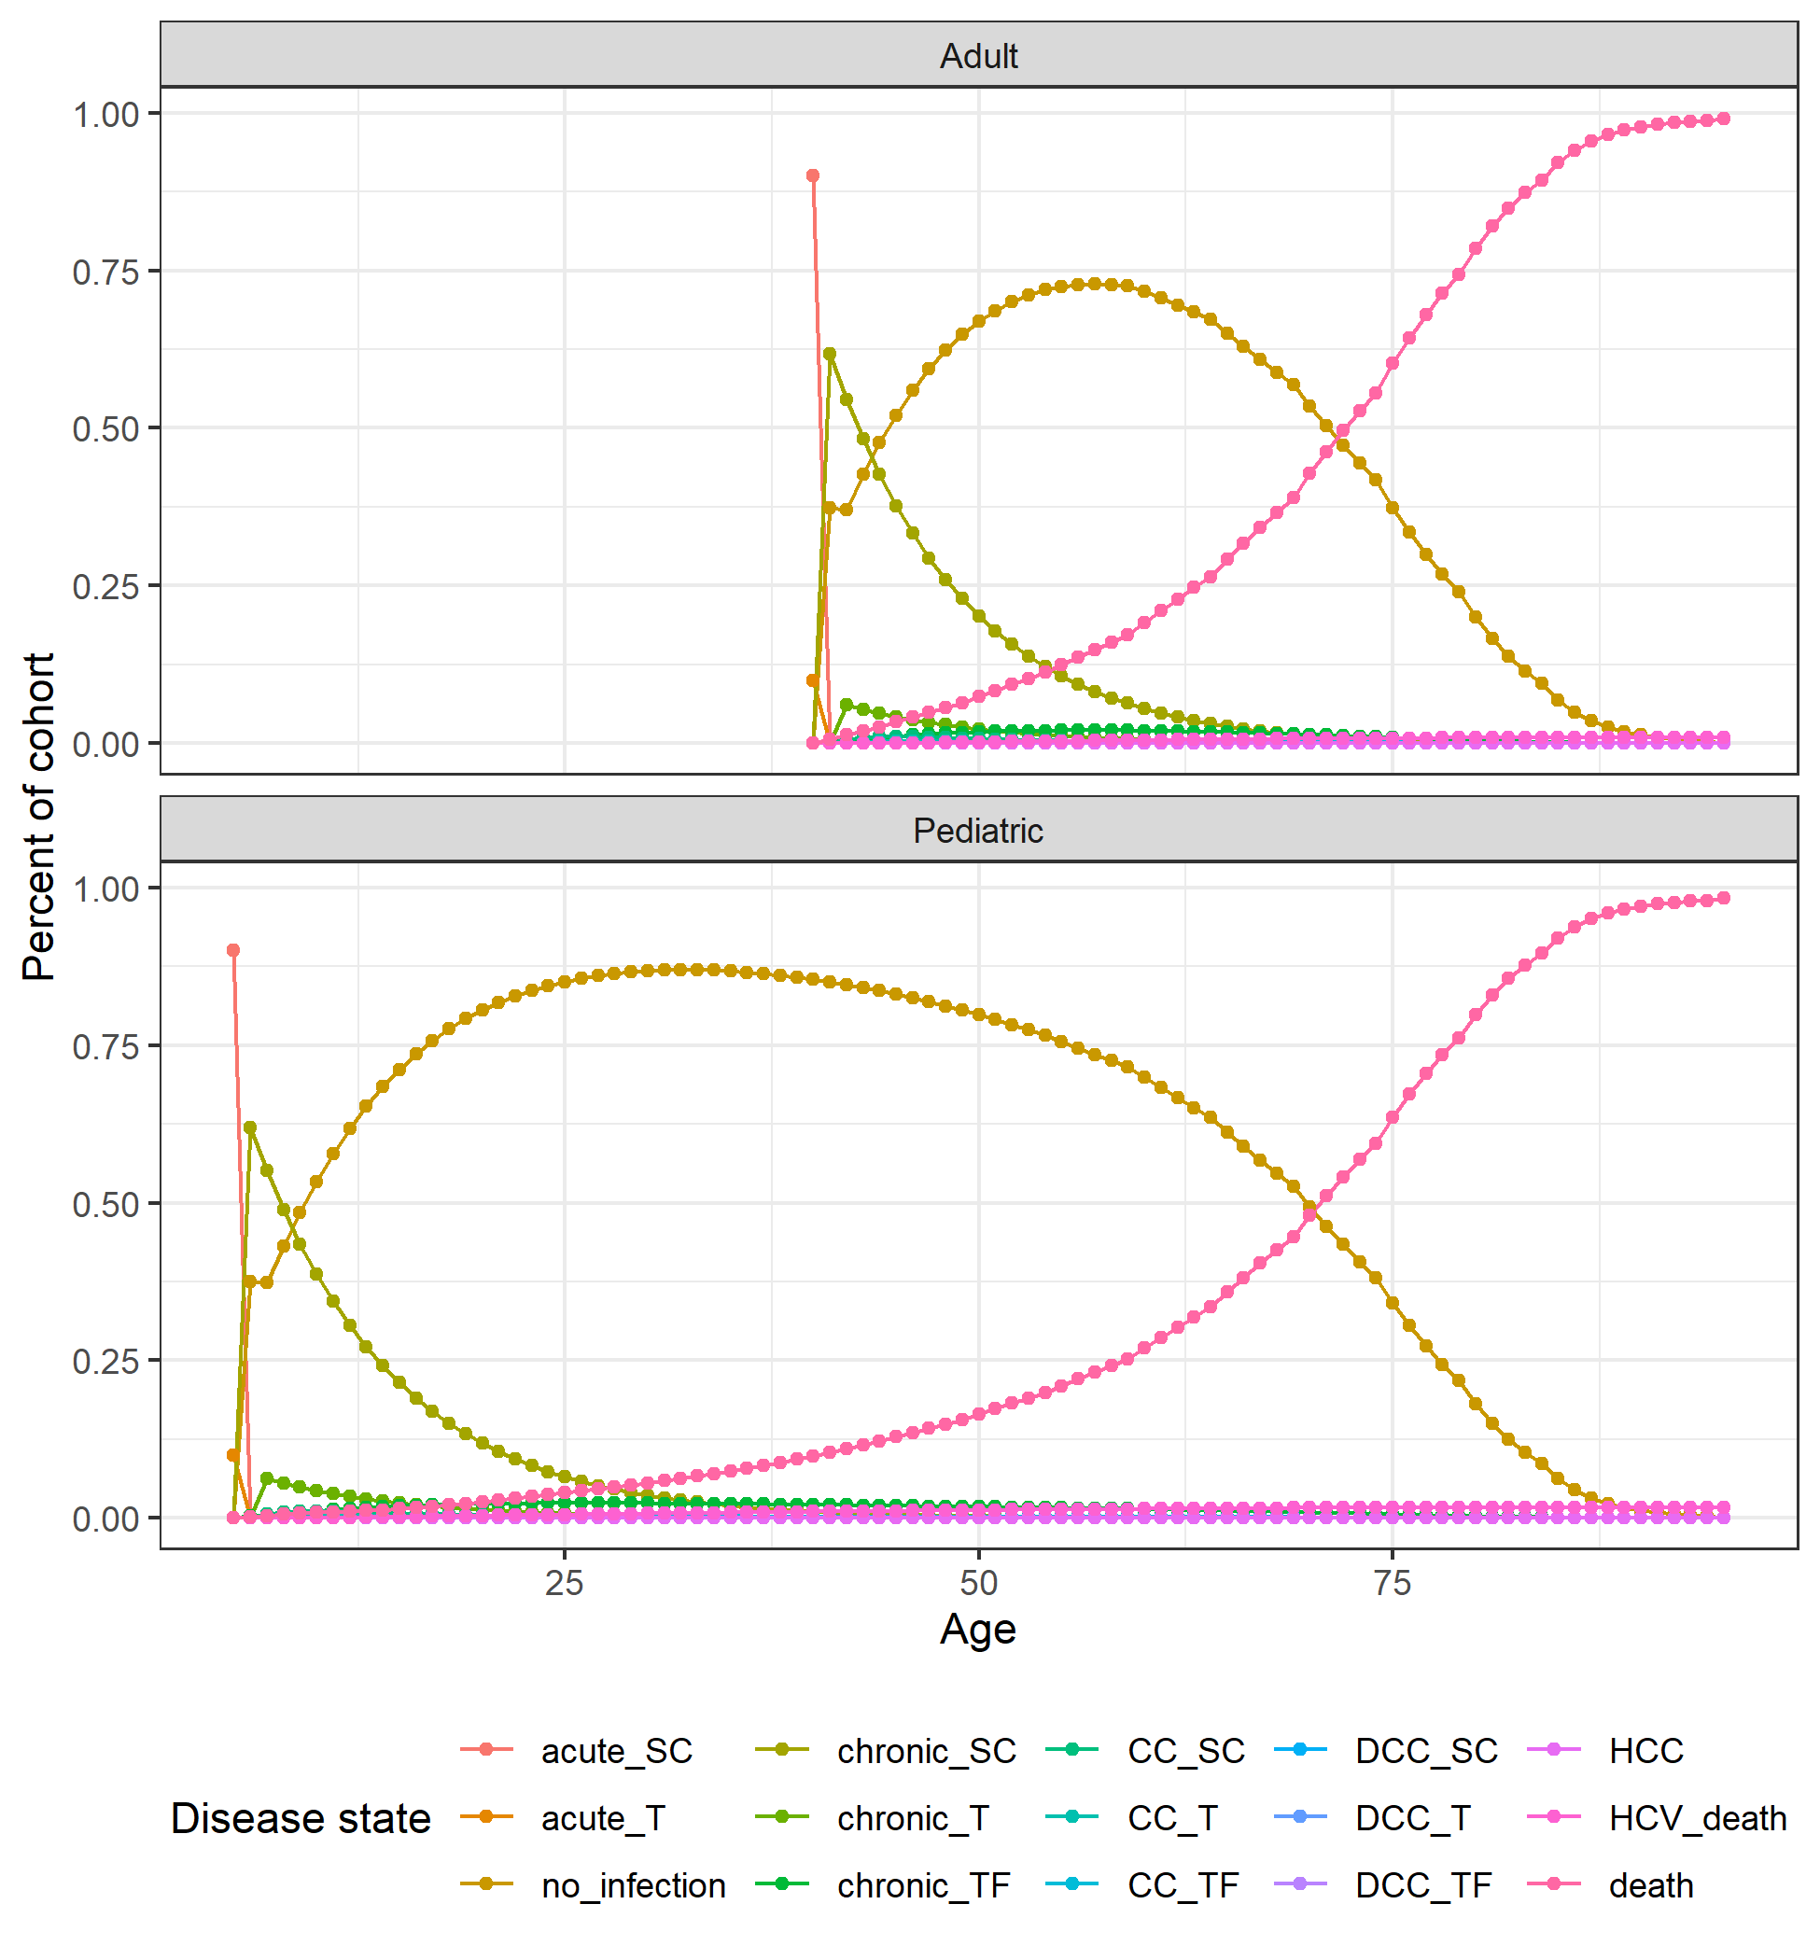

**Fig. S6.** Markov trace plot for HCV pediatric and adult cohorts. Disease state names: acute_SC, Acute subclinical; acute_T, Acute on AVT; CC_SC, Compensated cirrhosis subclinical; CC_T, Compensated cirrhosis on AVT; CC_TF, Compensated cirrhosis treatment failure; chronic_SC, Chronic HCV subclinical; chronic_T, Chronic HCV on AVT; chronic_TF, Chronic HCV treatment failure; DCC_SC, Decompensated cirrhosis subclinical; DCC_T, Decompensated cirrhosis on AVT; DCC_TF, Decompensated cirrhosis treatment failure; HCC, Hepatocellular carcinoma; HCV_death, HCV-related death; init, Initiation; no_infection, No infection; death, Other-cause death.

##### 

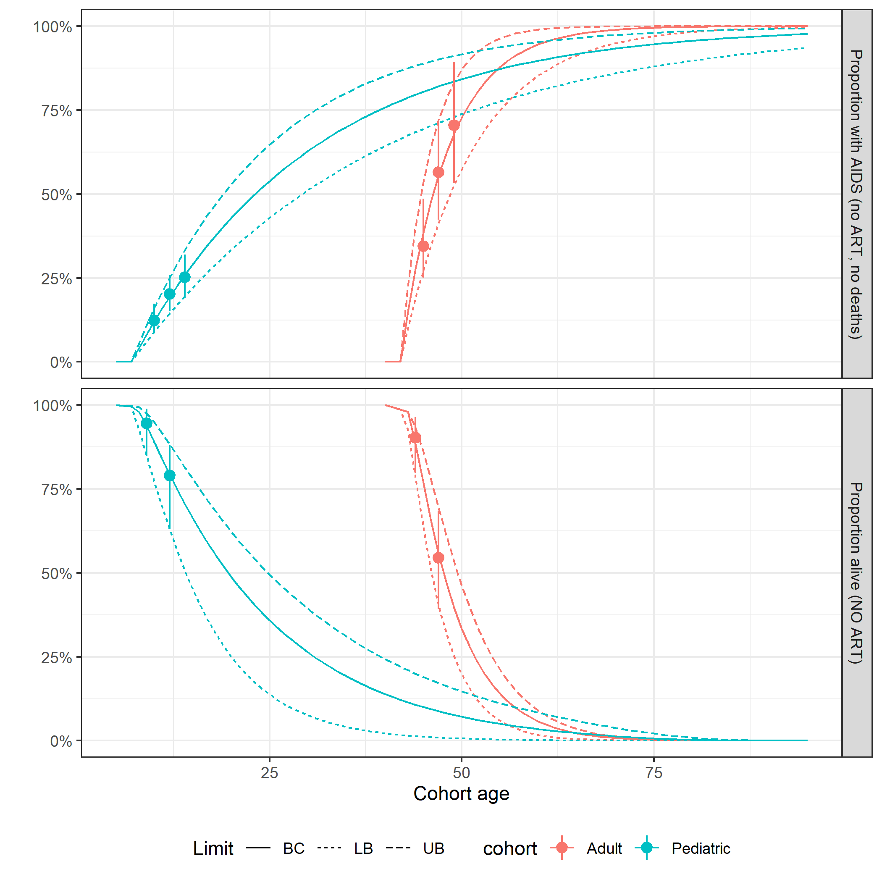

**Fig. S7.** Calibration plots for HIV natural history transition probabilities.